FUTURE AGRI: THE NEXT GENERATION OF AI ENABLED SMART FARMING
A PROJECT REPORT
Submitted by

AKSHAYA M V 960321104012

ANISHA M 960321104013

ANJUSHA S 960321104014

AYARIN JUSME J V 960321104022

In partial fulfillment for the award of the degree
of

BACHELOR OF ENGINEERING
IN
COMPUTER SCIENCE AND ENGINEERING

BETHLAHEM INSTITUTE OF ENGINEERING,
KARUNGAL

ANNA UNIVERSITY: CHENNAI 600 025
MAY 2025
ANNA UNIVERSITY: CHENNAI 600 025

BONAFIDE CERTIFICATE
Certified that this project report titled “FUTURE AGRI: THE NEXT GENERATION OF AI ENABLED SMART FARMING” is the bonafide work of “AKSHAYA M V (960321104012), ANISHA M (960321104013), ANJUSHA S (960321104014), AYARIN JUSME J V(960321104022)” who carried out the project work under my supervision.

SIGNATURE | SIGNATURE
Ms. G MARLY | Ms. FEBIN RANI L
HEAD OF THE DEPARTMENT | SUPERVISOR
Assistant Professor | Assistant Professor
Computer science and Engineering | Computer science and Engineering
Bethlahem Institute of Engineering | Bethlahem Institute of Engineering
Karungal, Kanyakumari Dist. | Karungal, Kanyakumari Dist.
Submitted for the Project Viva-Voce Examination held on ……………

INTERNAL EXAMINER EXTERNAL EXAMINER

ACKNOWLEDGEMENT
First and foremost, we consider it is the cardinal duty to thank ALMIGHTY GOD for his grace and blessings throughout the project.
We express our heart thanks to our Chairman Shri. N GERALD SELVA RAJA, for providing full facilities and Technical environment to start this project work.
We express our heartfelt gratitude to the Director Er. T ISAN, for our Institute for his constant support. We express our heartfelt gratitude to the Principal Dr. C EMMY PREMA of our Institute for her constant support.
We extent our thanks to ever loving Head of the Department Ms. G MARLY, Assistant Professor, Department of Computer Science and Engineering, for rendering her full supports both mentally and technically by encouraging us at all times we needed it.
We would like to express our whole hearted thanks to our Ms. FEBIN RANI L, Assistant Professor, Department of Computer Science and Engineering, to meet all challenges to come up with our project victoriously.
We extent our sincere thanks to all the Teaching and Non-Teaching Staff Members in Department of Computer Science and Engineering for their valuable help and supports.
ABSTRACT
Smart farming is an innovative approach that leverages ML and the Internet of Things (IoT) to optimize agricultural processes. Traditional farming methods often result in inefficient resource utilization, unpredictable yields, and susceptibility to environmental changes. This project aims to enhance precision agriculture by integrating IoT sensors, real-time data analytics, and predictive modeling to monitor and improve farming operations. IoT sensors collect real-time data on soil moisture, temperature, humidity, and crop health, which is then processed using machine learning algorithms to predict crop yield, detect diseases, and optimize irrigation schedules. Cloud-based data processing ensures large-scale data storage and trend analysis, enabling data-driven decision-making. Additionally, the system provides automated alerts and recommendations to farmers, helping them take proactive measures against pest infestations, adverse weather conditions, and inefficient resource use. The implementation of ML-driven smart farming leads to increased productivity, reduced operational costs, and sustainable agricultural practices. By integrating advanced AI-powered decision-making, this project contributes to food security, efficient resource management, and environmental conservation, making agriculture more resilient and technology-driven.

TABLE OF CONTENTS
CHAPTER NO. | TITLE | PAGE NO.
 | ABSTRACT | i
 | LIST OF FIGURES | vi
 | LIST OF ABBREVIATIONS | vii
1 | INTRODUCTION | 1
 | - INTERNET OF THINGS | 4
 | - MACHINE LEARNING | 7
 | - OVERVIEW OF PROJECT | 9
 | - PROBLEM STATEMENT | 11
 | - OBJECTIVES | 12
 | LITERATURE SURVEY | 13
 | - ESTIMATION OF CROP YIELD FROM COMBINED OPTICAL AND SAR IMAGERY USING GAUSSIAN KERNEL REGRESSION | 13
 | - HISTIF: A NEW SPATIOTEMPORAL IMAGE FUSION METHOD FOR HIGH-RESOLUTION MONITORING OF CROPS AT THE SUBFIELD LEVEL | 13
 | - A DECISION SUPPORT FRAMEWORK FOR NATIONAL CROP PRODUCTION PLANNING | 14
 | - CROP TYPE CLASSIFICATION BY DESIS HYPERSPECTRAL IMAGERY AND MACHINE LEARNING ALGORITHMS | 15
 | - AAVI: A NOVEL APPROACH TO ESTIMATING LEAF NITROGEN CONCENTRATION IN RICE FROM UNMANNED AERIAL VEHICLE MULTISPECTRAL IMAGERY AT EARLY AND MIDDLE GROWTH STAGES | 15
 | - AN OBJECT-BASED APPROACH FOR MAPPING CROP COVERAGE USING MULTISCALE WEIGHTED AND MACHINE LEARNING METHODS | 16
 | - HOW TO FEED A GROWING POPULATION, AN IOT APPROACH TO CROP HEALTH AND GROWTH | 16
 | - A NOVEL MODEL FOR OPTIMIZATION OF RESOURCE UTILIZATION IN SMART AGRICULTURE SYSTEM USING IOT (SMAIOT) | 17
 | - IOT AND MACHINE LEARNING IN AGRICULTURE: A COMPARATIVE REVIEW OF SMART FARMING SOLUTIONS | 18
 | - EFFICIENT SMART FARM SYSTEM USING MACHINE LEARNING | 18
 | SYSTEM ANALYSIS | 20
 | - EXISTING SYSTEM | 20
 | - DISADVANTAGES | 21
 | - PROPOSED SYSTEM | 22
 | - ADVANTAGES | 24
 | - ALGORITHM | 24
 | - CONVOLUTIONAL NEURAL NETWORK | 24
 | - LONG-SHORT TERM MEMORY | 30
 | SYSTEM DESIGN | 33
 | - BLOCK DIAGRAM | 33
 | - DATA FLOW DIAGRAM | 35
 | - MODULES | 37
 | - DATA COLLECTION | 37
 | - DATA PREPROCESSING | 38
 | - DEEP LEARNING MODEL | 39
 | - DECISION SUPPORT AND ALERT SYSTEM | 39
 | - SMART IRRIGATION AND PRECISION FARMING | 40
 | SYSTEM DESCRIPTION | 42
 | - HARDWARE DESCRIPTION | 42
 | - ESP32 IOT MODULE | 42
 | - TEMPERATURE SENSOR | 44
 | - SOIL MOISTURE SENSOR | 45
 | - HUMIDITY SENSOR | 46
 | - LIGHT INTENSITY SENSOR | 47
 | - PH SENSOR | 49
 | - SOFTWARE DESCRIPTION | 50
 | - ARDUINO IDE | 50
 | - JUPYTER NOTEBOOK | 53
 | - EMBEDDED C | 54
 | - PYTHON PROGRAMMING | 55
 | RESULTS AND DISCUSSION | 58
 | - RESULTS | 58
 | - DISCUSSION | 65
 | CONCLUSION AND FUTURE WORK | 67
 | - CONCLUSION | 67
 | - FUTURE WORK | 67
 | APPENDIX | 69
 | - SOURCE CODE | 69
 | REFERENCES | 85

LIST OF FIGURES
FIGURE NO. | TITLE | PAGE NO.
1.1 | IoT Structure | 5
1.2 | Machine Learning | 8
3.1 | Neural Network with Convolutional Layers | 25
3.2 | Long Short-Term Memory (LSTM) | 31
4.1 | Block Diagram of Proposed System | 33
4.2 | Data Flow Diagram | 35
5.1 | ESP32 Microcontroller | 43
5.2 | Temperature Sensor | 45
5.3 | Soil Moisture Sensor | 46
5.4 | Humidity Sensor | 47
5.5 | LDR Sensor | 49
5.6 | pH Sensor | 50
5.7 | Arduino IDE | 52
5.8 | Jupyter Notebook | 53
5.9 | Embedded C Programming | 55
5.10 | Python Programming | 56
6.1 | Smart Farming Interface | 60
6.2 | Disease Prediction | 61
6.3 | Fertilizer Recommendation | 62
6.4 | Water Requirement Estimator | 63
6.5 | Crop Recommendation | 64
6.6 | Weather Forecast Module | 64
6.7 | Yield Prediction | 64
LIST OF ABBREVIATIONS
ABBREVIATION | FULL FORM
AI | Artificial Intelligence
ML | Machine Learning
DL | Deep Learning
IoT | Internet of Things
CNN | Convolutional Neural Network
LSTM | Long Short-Term Memory
RGB | Red Green Blue
API | Application Programming Interface
GPS | Global Positioning System
NPK | Nitrogen, Phosphorus, Potassium
RH | Relative Humidity
UAV | Unmanned Aerial Vehicle
SVM | Support Vector Machine
KNN | K-Nearest Neighbors
GUI | Graphical User Interface
IDE | Integrated Development Environment
RAM | Random Access Memory
ADC | Analog to Digital Converter
SPI | Serial Peripheral Interface
PWM | Pulse Width Modulation
DHT | Digital Humidity and Temperature sensor

CHAPTER 1

INTRODUCTION
Agriculture is practiced by more than 70% of the Indian people. As a result, crop production and management are critical components of assuring maximum field productivity. Crop production is required to feed a country's vast population. As a result, people rely on crops for food. As a result, the fundamental purpose of this research is to use artificial intelligence (AI) (machine learning and deep learning) to predict agricultural yield output. The current focus of this research is on comparing machine learning and deep learning models for agricultural production prediction. The data may also be used to develop an efficient model and optimize it in order to produce accurate crop and overall production estimates.
The current study takes a look at how Machine Learning and Deep Learning algorithms compare. Many Artificial Intelligence approaches may be used to forecast crop yield. It is critical to understand which models perform better in order to predict. This research helps to determine which model performs best on sequential agriculture data. The agriculture data was subjected to two algorithms: Random Forest and Sequential Deep Learning. Before feeding the data to the models, it was label encoded. Because this is a regression problem, the R2 score of both models was used to evaluate them
Crop production analysis is the process of evaluating the performance and productivity of agricultural crops using various quantitative and qualitative methods. It involves collecting and analyzing data on crop yields, soil quality, weather conditions, pest and disease outbreaks, and other factors that can impact crop production. The goal of crop production analysis is to identify the strengths and weaknesses of the agricultural system, develop strategies to improve crop yield and quality, and ultimately maximize profitability for farmers. Crop production analysis is important for farmers, agricultural researchers, policymakers, and other stakeholders involved in agriculture to make informed decisions about crop management practices, resource allocation, and investments in agricultural technology and infrastructure.
Crop production analysis is a critical component of modern agriculture, as it enables farmers to make informed decisions about their crops, maximize their yields, and ultimately increase their profitability. The analysis involves the collection and analysis of data on various factors that affect crop production, including soil quality, weather patterns, pest and disease outbreaks, and agricultural inputs such as fertilizers and pesticides.
One of the main objectives of crop production analysis is to identify the strengths and weaknesses of the agricultural system. By examining the yield data of a particular crop over multiple years, farmers can determine whether the productivity of the crop has increased or decreased over time, and identify the factors that have contributed to these changes. For example, if a crop has experienced a decline in yield, the analysis may reveal that soil nutrients have been depleted or that there has been an increase in pest or disease pressure.
In addition to identifying the factors that affect crop production, crop production analysis can also be used to develop strategies to improve crop yields and quality. By examining the factors that contribute to crop success, farmers can make informed decisions about the use of fertilizers and pesticides, select crop varieties that are more resistant to pests and diseases, and optimize irrigation and other inputs to maximize yields.
Crop production analysis is also important for policymakers and researchers, as it can help them develop more effective agricultural policies and technologies. By analyzing crop production data from different regions and crops, policymakers can identify the areas where additional research and investment is needed to improve crop productivity, reduce waste and inefficiencies, and promote sustainable agricultural practices. Similarly, researchers can use crop production analysis to identify the genetic and environmental factors that affect crop yields and develop new crop varieties that are more resilient and productive.
There are various methods used in crop production analysis, including statistical analysis, machine learning, and geographic information systems (GIS). Statistical analysis involves the use of mathematical models to identify patterns and relationships in crop production data. Machine learning algorithms such as Support Vector Machines (SVMs) and K-Nearest Neighbors (KNN) can also be used to analyze crop production data, enabling more accurate predictions of crop yields and the factors that contribute to crop success. GIS can be used to analyze spatial data such as soil types, land use patterns, and climate data, providing valuable insights into the geographic factors that affect crop production.
In conclusion, crop production analysis is a critical component of modern agriculture, enabling farmers, policymakers, and researchers to make informed decisions about crop management practices, investments, and policies. By collecting and analyzing data on various factors that affect crop production, such as soil quality, weather patterns, and pest and disease pressure, farmers can optimize their inputs, maximize their yields, and ultimately increase their profitability. Similarly, policymakers and researchers can use crop production analysis to identify the areas where additional research and investment is needed to improve crop productivity, reduce waste and inefficiencies, and promote sustainable agricultural practices.

INTERNET OF THINGS
Internet of Things (IoT) refers to the stringent connectedness between digital and physical world.
Various researchers have described IoT in multitude forms:
- “A dynamic global network infrastructure with self-configuring capabilities based on standard and interoperable communication protocols where physical and virtual ’Things’ have identities, physical attributes, and virtual personalities and use intelligent interfaces, and are seamlessly integrated into the information network”.
- “3A concept: anytime, anywhere and any media, resulting into sustained ratio between radio and man around 1:1”.
- ‘‘Things having identities and virtual personalities operating in smart spaces using intelligent interfaces to connect and communicate within social, environmental, and user contexts”. The semantic meaning of ‘‘Internet of Things” is presented as ‘‘a world-wide network of interconnected objects uniquely addressable, based on standard communication protocols”.
- “A global infrastructure for the information society enabling advanced services by interconnecting (physical and virtual) things based on, existing and evolving, interoperable information and communication technologies”.
The Internet of things (IoT) is the network of physical devices, vehicles, home appliances and other items embedded with electronics, software, sensors, actuators, and connectivity which enables these objects to connect and exchange data. Each thing is uniquely identifiable through its embedded computing system but is able to inter-operate within the existing Internet infrastructure. The figure of online capable devices increased 31% from 2016 to 8.4 billion in 2017. Experts estimate that the IoT will consist of about 30 billion objects by 2020. It is also estimated that the global market value of IoT will reach $7.1 trillion by 2020.
The IoT allows objects to be sensed or controlled remotely across existing network infrastructure, creating opportunities for more direct integration of the physical world into computer-based systems, and resulting in improved efficiency, accuracy and economic benefit in addition to reduced human intervention. When IoT is augmented with sensors and actuators, the technology becomes an instance of the more general class of cyber-physical systems, which also encompasses technologies such as smart grids, virtual power plants, smart homes, intelligent transportation and smart cities.
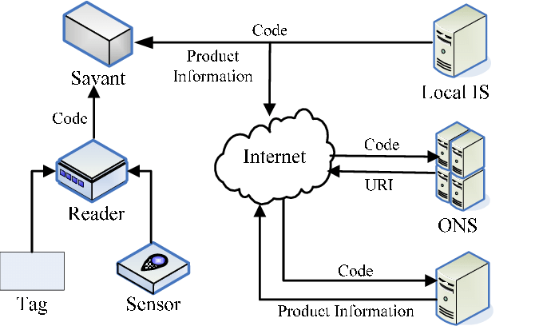
Fig: 1.1: IoT structure
"Things", in the IoT sense, can refer to a wide variety of devices such as heart monitoring implants, biochip transponders on farm animals, cameras streaming live feeds of wild animals in coastal waters, automobiles with built-in sensors, DNA analysis devices for environmental/food/pathogen monitoring, or field operation devices that assist firefighters in search and rescue operations. Legal scholars suggest regarding "things" as an "inextricable mixture of hardware, software, data and service".
These devices collect useful data with the help of various existing technologies and then autonomously flow the data between other devices.
The Internet of things (IoTs) can be characterized as interfacing the different sorts of items like advanced mobile phones, PC and Tablets to web, which gets extremely unique kind of correspondence amongst things and individuals and furthermore between things. With the presentation of IoTs, the innovative work of home robotization are getting to be plainly prominent in the current days. A large portion of the gadgets are controlled and observed for helps the individual. Also, different remote advancements help in associating from remote spots to enhance the insight of home condition.
A propelled system of IoT is being shaped when a person need interfacing with different things. IoTs innovation is utilized to come in with inventive thought and awesome development for brilliant homes to enhance the expectations for everyday comforts of life. The IoT-based design gives abnormal state adaptability at the correspondence and data. It is an approach which is pertinent in a wide range of conditions, for example, tolerant observing framework, security, activity flag control or controlling different applications. The IoT extend means to draw out the different chances of utilizing IPv6 and other related guidelines to beat the inconveniences utilizing of the Internet of Things. The IoT ventures demonstrates a predominant and exhaustive investigation of all sensible functionalities, components and different conventions that can be utilized for building IoT models however interconnections may happen between all entirely unexpected IoT applications. As in the systems administration field, where a few arrangements risen at his earliest stages to leave place to a typical model, the TCP/IP convention suite, the rise of a typical reference display for the IoT space and the distinguishing proof of reference structures can prompt a speedier, more engaged improvement and an exponential increment of IoT-related arrangements. These arrangements can give a vital preferred standpoint to develop economies, as new plans of action can use those mechanical arrangements giving space to monetary advancement.
  - MACHINE LEARNING
Machine learning is an application of artificial intelligence (AI) that provides systems the ability to automatically learn and improve from experience without being explicitly programmed. Machine learning focuses on the development of computer programs that can access data and use it learn for themselves.
The process of learning begins with observations or data, such as examples, direct experience, or instruction, in order to look for patterns in data and make better decisions in the future based on the examples that we provide. The primary aim is to allow the computers learn automatically without human intervention or assistance and adjust actions accordingly. Machine learning algorithms are often categorized as supervised or unsupervised.
Supervised Machine Learning:
Supervised machine learning algorithms can apply what has been learned in the past to new data using labeled examples to predict future events. Starting from the analysis of a known training dataset, the learning algorithm produces an inferred function to make predictions about the output values. The system is able to provide targets for any new input after sufficient training. The learning algorithm can also compare its output with the correct, intended output and find errors in order to modify the model accordingly.
Unsupervised Machine Learning:
In contrast, unsupervised machine learning algorithms are used when the information used to train is neither classified nor labeled. Unsupervised learning studies how systems can infer a function to describe a hidden structure from unlabeled data. The system doesn’t figure out the right output, but it explores the data and can draw inferences from datasets to describe hidden structures from unlabeled data.
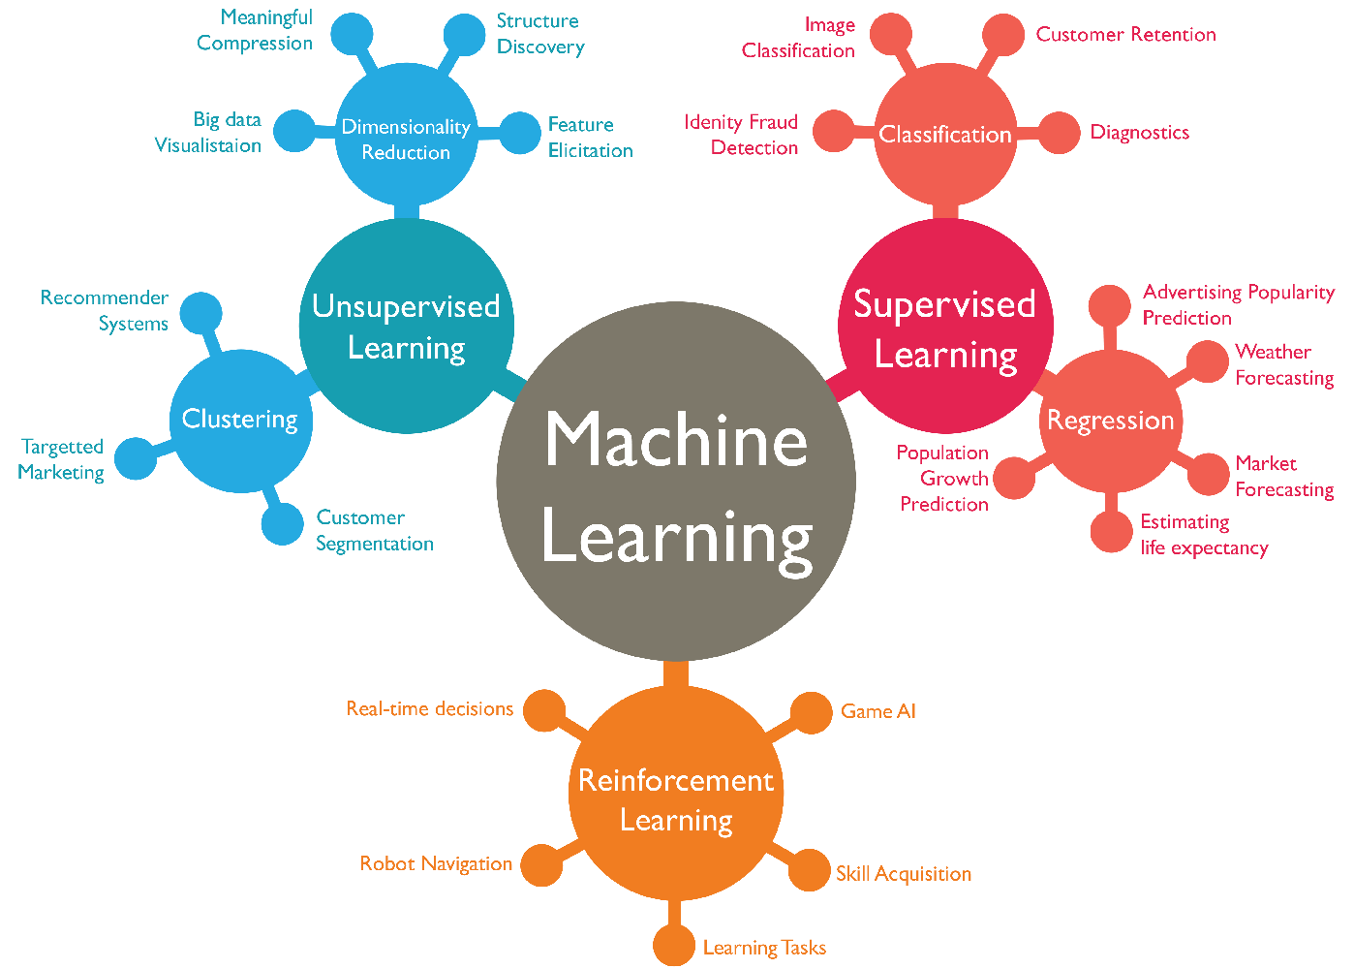
Fig 1.2: Machine Learning
Semi-Supervised Machine Learning:
Semi-supervised machine learning algorithms fall somewhere in between supervised and unsupervised learning, since they use both labeled and unlabeled data for training – typically a small amount of labeled data and a large amount of unlabeled data. The systems that use this method are able to considerably improve learning accuracy. Usually, semi-supervised learning is chosen when the acquired labeled data requires skilled and relevant resources in order to train it / learn from it. Otherwise, acquiring unlabeled data generally doesn’t require additional resources.
Reinforcement Machine Learning:
Reinforcement machine learning algorithms is a learning method that interacts with its environment by producing actions and discovers errors or rewards. Trial and error search and delayed reward are the most relevant characteristics of reinforcement learning. This method allows machines and software agents to automatically determine the ideal behavior within a specific context in order to maximize its performance. Simple reward feedback is required for the agent to learn which action is best; this is known as the reinforcement signal.
Machine learning enables analysis of massive quantities of data. While it generally delivers faster, more accurate results in order to identify profitable opportunities or dangerous risks, it may also require additional time and resources to train it properly. Combining machine learning with AI and cognitive technologies can make it even more effective in processing large volumes of information.

1.3 OVERVIEW OF PROJECT
The Smart Farming project is built on the foundation of integrating modern technologies like the Internet of Things (IoT), Machine Learning (ML), and Deep Learning (DL) into agricultural practices to address long-standing challenges in farming. Traditional farming methods often rely on manual observation, historical knowledge, and trial-and-error approaches, which can lead to inconsistent crop yields, inefficient use of resources, and a lack of timely responses to environmental changes. This project aims to overcome these limitations by introducing an intelligent, automated system that can continuously monitor, analyze, and respond to real-time conditions in the field. By doing so, it empowers farmers to make better decisions, increase productivity, and reduce their environmental footprint.
At the heart of the system are IoT sensors and imaging devices that gather a wide range of agricultural data. These include soil moisture levels, ambient temperature, humidity, light intensity, and soil pH values, all of which influence crop growth and health. Additionally, drones and high-resolution cameras capture images of crops, which are crucial for detecting visual signs of disease, pest infestations, and nutrient deficiencies. The real-time data collected from these sources is transmitted to a cloud-based platform for processing and analysis, enabling remote monitoring and centralized decision-making. This data is not only voluminous but also complex, necessitating the use of sophisticated algorithms capable of interpreting it effectively.
To address the complexity of the collected data, the system employs both machine learning and deep learning techniques. Convolutional Neural Networks (CNNs) are used for image analysis, allowing the system to detect diseases and pests with high precision by recognizing patterns in leaf structures and discolorations. Long Short-Term Memory (LSTM) networks, a type of recurrent neural network (RNN), are applied to time-series data from sensors to forecast future conditions such as soil moisture trends, irrigation needs, and potential risks like drought or excessive rainfall. These models enable the system to not only react to current conditions but also anticipate future challenges, facilitating proactive farm management.
Another critical component of the system is its decision support and automation capability. Based on the insights derived from the ML and DL models, the system provides farmers with actionable recommendations on irrigation scheduling, fertilization, and disease control. These recommendations are delivered through a user-friendly interface that includes a web-based dashboard and a mobile application, ensuring accessibility for farmers in both rural and connected environments. Moreover, the system can automate certain responses, such as adjusting irrigation based on soil moisture readings, through smart actuators, thereby reducing labor requirements and ensuring timely action even in the absence of human intervention.
This smart farming system represents a significant leap forward in the modernization of agriculture. By combining real-time sensing, intelligent data analysis, and automated decision-making, it enables more precise, efficient, and sustainable farming practices. The project demonstrates how technology can transform agriculture into a data-driven industry capable of meeting the demands of food production while preserving natural resources. It not only supports the individual farmer in making better decisions but also contributes to broader goals such as climate resilience, food security, and environmental sustainability.

1.4 PROBLEM STATEMENT
Modern agriculture faces a range of critical challenges, including inefficient resource utilization, declining soil quality, unpredictable weather patterns, pest infestations, and crop diseases—all of which contribute to inconsistent yields and increased production costs. Traditional farming methods, which rely heavily on manual labor and historical experience, often lack the precision and responsiveness needed to manage these issues effectively. As a result, farmers struggle to make timely and informed decisions, leading to suboptimal use of water, fertilizers, and pesticides, as well as increased vulnerability to environmental fluctuations. In an era where global food demand is rising and natural resources are becoming increasingly scarce, there is a pressing need for a smarter, data-driven approach to agriculture. This project addresses the problem by developing an intelligent farming system that integrates IoT devices with machine learning and deep learning models to monitor real-time field conditions, predict future trends, and support automated decision-making. The goal is to optimize farming operations, reduce resource wastage, enhance crop health, and ensure sustainable agricultural practices.

1.5 OBJECTIVES
- To collect real-time agricultural data using IoT sensors (e.g., soil moisture, temperature, humidity, and pH levels).
- To apply machine learning and deep learning models (CNN and LSTM) for data analysis and prediction.
- To forecast irrigation needs, crop yield, and environmental risks using time-series data.
- To provide automated alerts and recommendations for irrigation, fertilization, and disease control.
- To reduce water, fertilizer, and pesticide usage through precision farming techniques.

CHAPTER 2
LITERATURE SURVEY

2.1 Y. Alebele et al., "Estimation of Crop Yield From Combined Optical and SAR Imagery Using Gaussian Kernel Regression," in IEEE Journal of Selected Topics in Applied Earth Observations and Remote Sensing, vol. 14, pp. 10520-10534, 2021, doi: 10.1109/JSTARS.2021.3118707.
The synthetic aperture radar (SAR) interferometric coherence can complement optical data for the estimation of crop growth parameters, but it has not been yet investigated for predicting crop yield. Many studies have used machine-learning methods, such as neural networks, random forest, and Gaussian process regression, to estimate crop yield from remotely sensed data. However, the performance depends on the amount of available ground truth data. This study proposed Gaussian kernel regression for rice yield estimation from optical and SAR imagery using a limited amount of ground truth data. The main objective was to investigate the synergetic use of Sentinel-2 vegetation indices and Sentinel-1 interferometric coherence data through Gaussian kernel regression for estimating rice grain yield.

2.2 J. Jiang et al., "HISTIF: A New Spatiotemporal Image Fusion Method for High-Resolution Monitoring of Crops at the Subfield Level," in IEEE Journal of Selected Topics in Applied Earth Observations and Remote Sensing, vol. 13, pp. 4607-4626, 2020, doi: 10.1109/JSTARS.2020.3016135.
Satellite-based time-series crop monitoring at the subfield level is essential to the efficient implementation of precision crop management. Existing spatiotemporal image fusion techniques can be helpful, but they were often proposed to generate medium-resolution images. This study proposed a high-resolution spatiotemporal image fusion method (HISTIF) consisting of filtering for cross-scale spatial matching (FCSM) and multiplicative modulation of temporal change (MMTC). In FCSM, they considered both point spread function effect and geo-registration errors between fine and coarse resolution images. Subsequently, MMTC used pixel-based multiplicative factors to estimate the temporal change between reference and prediction dates without image classification. The performance of HISTIF was evaluated using both simulated and real datasets with one from real Gaofen-1 (GF-1) and simulated Landsat-like/Sentinel-like images, and the other from real GF-1 and real Landsat/Sentinel-2 data on two sites.

2.3 N. Rasheed, S. A. Khan, A. Hassan and S. Safdar, "A Decision Support Framework for National Crop Production Planning," in IEEE Access, vol. 9, pp. 133402-133415, 2021, doi: 10.1109/ACCESS.2021.3115801.
A decision support framework for defining planning parameters for national crop production. The proposed framework addresses the gaps in policymaking, the role of all stakeholders, and uses historical data of crop production in different sectors of land in optimizing the profits that shall meet the defined constraints including national requirement, and export demand of different crops. There are many agro-economy-based countries where agriculture is the main contributor to the GDP, while there are others who always struggle to meet the national need while optimizing the agro-economy component of the earnings. Crops are not always produced with keeping the demand and production balance. Rather, the crops are mostly produced according to the farmer’s ease and last year’s prices for profit maximization leading to excessive production of one type of crop, lowering of profit margins, and shortage of some key crops for national need.

2.4 N. Farmonov et al., "Crop Type Classification by DESIS Hyperspectral Imagery and Machine Learning Algorithms," in IEEE Journal of Selected Topics in Applied Earth Observations and Remote Sensing, vol. 16, pp. 1576-1588, 2023, doi: 10.1109/JSTARS.2023.3239756.
Developments in space-based hyperspectral sensors, advanced remote sensing, and machine learning can help crop yield measurement, modelling, prediction, and crop monitoring for loss prevention and global food security. However, precise and continuous spectral signatures, important for large-area crop growth monitoring and early prediction of yield production with cutting-edge algorithms, can be only provided via hyperspectral imaging. Therefore, this article used new-generation Deutsches Zentrum für Luft- und Raumfahrt Earth Sensing Imaging Spectrometer (DESIS) images to classify the main crop types (hybrid corn, soybean, sunflower, and winter wheat) in Mezőhegyes (southeastern Hungary). A Wavelet-attention convolutional neural network (WA-CNN), random forest and support vector machine (SVM) algorithms were utilized to automatically map the crops over the agricultural lands.

2.5 W. Wang et al., "AAVI: A Novel Approach to Estimating Leaf Nitrogen Concentration in Rice From Unmanned Aerial Vehicle Multispectral Imagery at Early and Middle Growth Stages," in IEEE Journal of Selected Topics in Applied Earth Observations and Remote Sensing, vol. 14, pp. 6716-6728, 2021, doi: 10.1109/JSTARS.2021.3086580.
Accurate and timely monitoring of leaf nitrogen concentration (LNC) in rice is crucial to optimize nitrogen fertilizer management and reduce environmental pollution. Existing vegetation indices (VIs) often perform well for high canopy cover conditions, but the performance becomes poor at early growth stages due to the significant exposure of background materials and the induced spectral mixing effect. This study proposed a novel approach to estimate the LNC at early and middle growth stages of paddy rice by using abundance adjusted VIs (AAVIs) from unmanned aerial vehicle (UAV) multispectral imagery. An AAVI was constructed by combining the traditional VI and the rice abundant from linear spectral mixture analysis of UAV imagery.

2.6 Z. Tang, H. Wang, X. Li, X. Li, W. Cai and C. Han, "An Object-Based Approach for Mapping Crop Coverage Using Multiscale Weighted and Machine Learning Methods," in IEEE Journal of Selected Topics in Applied Earth Observations and Remote Sensing, vol. 13, pp. 1700-1713, 2020, doi: 10.1109/JSTARS.2020.2983439.
Accurate mapping of crop distribution on Earth's surface aids in predicting grain production. Pattern classification along with remote sensing imagery can facilitate traditional manual field measurement techniques using machine learning. With the rapid increase in satellite sensor resolution, the object-based classification paradigm has increasingly been applied. However, scale parameter selection is always a difficult part of the object-based classification. Based on ensemble learning, this study proposes a classification method using the multiscale object-based weighted method which includes manual digitizing of crop distribution in the southern region of Jishan County, Shanxi Province, China, applying Gaofen-2 (GF-2) images.

2.7 V. Grimblatt, C. Jégo, G. Ferré and F. Rivet, "How to Feed a Growing Population, An IoT Approach to Crop Health and Growth," in IEEE Journal on Emerging and Selected Topics in Circuits and Systems, vol. 11, no. 3, pp. 435-448, Sept. 2021, doi: 10.1109/JETCAS.2021.3099778.
Humankind consumes the planet's resources beyond what the Earth can provide with estimations according 9.2 billion human beings in 2050 consuming yearly almost twice the resources the Earth can provide. Crop production needs to increase by 70% to be able to feed all the population. A convenient way to address this issue is to produce efficiently respecting the planet. Non-invasive technology at a low cost is a solution to monitor crop growth and health, helping small to medium farmers to increase the productivity keeping in mind the conservation of the planet. Circuits and Systems offer large range of possibilities. They propose to investigate IoT with medium cost sensors to deliver real time, affordable and precise data processing for agriculture producing an Automated Decision-Making Systems (ADMS).

2.8 K. A. Jani and N. K. Chaubey, "A Novel Model for Optimization of Resource Utilization in Smart Agriculture System Using IoT (SMAIoT)," in IEEE Internet of Things Journal, vol. 9, no. 13, pp. 11275-11282, 1 July1, 2022, doi: 10.1109/JIOT.2021.3128161.
Many countries have rich resources of land, rivers, groundwater, environment, and fertilizers availability. Agriculture is the main source of income for several country’s people. Since the last few decades, there are few resource shortages, such as groundwater and river water. People are unaware of the proper utilization of available valuable resources, which leads to the use of more resources for less crop production. One of the solutions of this problem is to design and implement an Internet of Things (IoT)-based smart framework for agriculture. In this article, they have proposed a smart agriculture framework to monitor different types of low-cost IoT sensors devices, which collects data from soil, air, water, and insects and makes appropriate decisions based on the analysis of sensors data.

2.9 P. Shankar, A. Thakur, H. Ansari, M. Bilal and P. A. Chaugule, "IoT and Machine Learning in Agriculture: A Comparative Review of Smart Farming Solutions," 2024 5th International Conference on Data Intelligence and Cognitive Informatics (ICDICI), Tirunelveli, India, 2024, pp. 306-310, doi: 10.1109/ICDICI62993.2024.10810798.
Smart agriculture utilizes IoT and ML technologies to revolutionize traditional farming practices. IoT sensors collect real-time environmental data, which ML algorithms analyze for tasks like soil classification, crop yield prediction, and disease detection. Various ML techniques, including deep learning models, are employed to improve accuracy and efficiency of the system. Applications range from automated livestock monitoring to efficient water management. Hybrid models combining different ML approaches often achieve superior results. Smart agriculture shows great potential for enhancing crop yields, reducing waste, and promoting sustainable practices to address global food security concerns.

2.10 Rashmirani Samantaray, Abdul Azeez and Nayana Hegde, "Efficient Smart Farm System Using Machine Learning", pp. 576-581, 2023.
The world around us is becoming increasingly mechanized because of technology. Due to their energy efficiency and reduced need for tiresome human labor, automatic systems are preferred over manual ones. Automation of agriculture is necessary to improve efficiency because it is the main economic sector in India and other emerging nations. It takes a lot of work to run a regular farm. Automation may effectively reduce the amount of physical work, facilitate, and speed up farming, and promote agricultural expansion. Farms and farmhouses engaged in agriculture are included in the concept of automation. This paper describes an automatic livestock monitoring system using machine learning for smart farms. The proposed system is implemented using Raspberry pi and sensors.

CHAPTER 3
SYSTEM ANALYSIS

EXISTING SYSTEM
Traditional machine learning (ML) techniques have played a significant role in the evolution of precision agriculture by enabling data-driven insights and automating certain aspects of farm management. These methods have been employed to analyze structured and semi-structured farm data for applications such as crop classification, yield prediction, pest and disease detection, and resource allocation. ML algorithms like Decision Trees, Random Forests, K-Nearest Neighbors (KNN), and particularly Support Vector Machines (SVM) have found widespread use in agricultural systems. Their capacity to model relationships within data has supported more efficient decision-making, replacing intuition-based farming with more analytical and systematic approaches.
Among these methods, Support Vector Machines have been particularly popular for tasks involving classification and pattern recognition. In agriculture, SVMs have been applied to distinguish between different crop types using multispectral or hyperspectral imagery, detect pest-infested crops, and identify early signs of disease based on leaf images. These models are known for their effectiveness in finding complex boundaries between classes, which is essential in identifying subtle differences in plant health. However, SVMs, like many traditional ML algorithms, require manual feature extraction—a process where relevant attributes (e.g., color, texture, or shape) are manually selected and engineered from raw data before being input into the model.
Despite their utility, these traditional ML systems face considerable limitations when dealing with large-scale, high-dimensional, and unstructured data—such as drone images, sensor streams, or satellite data. Manual feature extraction is time-consuming, and it can often miss nuanced patterns that are vital in detecting early-stage crop issues. Furthermore, these models struggle to generalize across different farm conditions and may deliver inconsistent performance in varied climatic or geographic regions. As agricultural datasets grow in complexity and volume, traditional ML techniques become less scalable and less capable of capturing the full richness of the data.
In summary, while traditional ML approaches have laid the groundwork for data analytics in agriculture, they are increasingly inadequate for handling the dynamic and complex nature of modern farming environments. Their reliance on manual preprocessing and limited capacity to model temporal or spatial patterns restrict their effectiveness. This shortfall creates an urgent need for more advanced, automated, and scalable technologies—such as deep learning and real-time IoT integration—which can process vast datasets, learn intricate patterns autonomously, and deliver more accurate, timely insights for precision farming.

Disadvantages
- Manual Feature Engineering
- Limited Scalability & Generalization
- Struggles with High-Dimensional Data
- Lower Accuracy in Complex Scenarios
- Static Nature & Lack of Real-Time Learning
- Computational Limitations & Processing Speed
- Lower Performance in Image-Based Applications

PROPOSED SYSTEM
The proposed smart farming system is designed as an integrated, intelligent framework that leverages IoT, machine learning, and deep learning technologies to transform traditional agriculture into a more efficient, sustainable, and data-driven process. At its core, the system begins with the deployment of various IoT sensors across the farm to monitor environmental and soil conditions in real time. These sensors capture crucial parameters such as soil moisture, temperature, humidity, pH levels, and light intensity—factors that directly influence crop growth and health. In addition to ground-level sensing, the system incorporates aerial monitoring through drones and high-resolution cameras, which capture images of crops from different angles. These images are vital for detecting visual symptoms of plant diseases, pest infestations, and nutrient deficiencies. Real-time weather data is also integrated to provide contextual information for decision-making.
Once the data is collected, it is transferred to a central cloud-based platform where the data pre-processing module comes into action. Sensor data undergoes normalization and feature extraction to prepare it for time-series analysis, while image data is cleaned, segmented, and augmented to enhance the performance of image recognition models. The system then uses deep learning algorithms to analyze this data. Convolutional Neural Networks (CNNs) are employed for analyzing images and identifying signs of disease or stress in crops with high accuracy. At the same time, Long Short-Term Memory (LSTM) networks analyze the time-series data from sensors to forecast future trends such as irrigation needs, temperature fluctuations, and potential crop failure risks. These models are trained on historical and real-time data, and continuously updated to improve prediction accuracy and adaptability.
Based on the insights generated by the CNN and LSTM models, the system activates the decision support and alert module, which interprets predictions and translates them into actionable recommendations. This module provides farmers with real-time alerts on critical issues such as pest outbreaks, extreme weather events, or abnormal crop behavior. It also offers guidance on when to irrigate, how much water or fertilizer to apply, and which disease control measures to take. The information is delivered through a user-friendly dashboard and mobile application, ensuring accessibility for users with varying levels of technical expertise. The intuitive interface allows farmers to monitor field conditions, view visual analytics, and respond quickly to emerging threats, thereby improving operational efficiency and reducing dependence on guesswork.
The final stage of the system involves automated execution through the smart irrigation and precision farming module. This module uses the predictive outputs from the deep learning models to control irrigation systems, ensuring that water is applied only when and where it is needed. Similarly, fertilization is carried out with precision, targeting specific areas of the field based on soil and crop requirements. This targeted approach minimizes resource wastage, reduces environmental impact, and enhances overall crop productivity. Through automation, the system reduces manual labor and enables timely interventions, even in the absence of human monitoring.
The proposed system is a comprehensive and scalable solution that bridges the gap between traditional farming practices and modern technological advancements. It combines real-time monitoring, intelligent analytics, predictive modeling, and automated execution to support sustainable and productive agriculture. By making farming more responsive, resource-efficient, and proactive, the system contributes to addressing global agricultural challenges such as food security, resource scarcity, and climate variability.

Advantages
- High accuracy in image-based classification tasks.
- Automated feature extraction, reducing manual effort.
- Scalable for large datasets collected from drones and IoT cameras/Sensors
- Handles sequential & time-series data efficiently.
- Learns long-term dependencies, making it useful for weather & crop predictions.

ALGORITHM

Convolutional Neural Network
In deep learning, a convolutional neural network (CNN, or ConvNet) is a class of artificial neural network (ANN), most commonly applied to analyze visual imagery. CNNs are also known as Shift Invariant or Space Invariant Artificial Neural Networks (SIANN), based on the shared-weight architecture of the convolution kernels or filters that slide along input features and provide translation-equivariant responses known as feature maps. Counter-intuitively, most convolutional neural networks are only equivariant, as opposed to invariant, to translation. They have applications in image and video recognition, recommender systems, image classification, image segmentation, medical image analysis, natural language processing, brain–computer interfaces, and financial time series.
Convolutional networks are a specialized type of neural networks that use convolution in place of general matrix multiplication in at least one of their layers or, in other words, A convolutional neural network (CNN) is a type of artificial neural network used in image recognition and processing that is specifically designed to process pixel data.
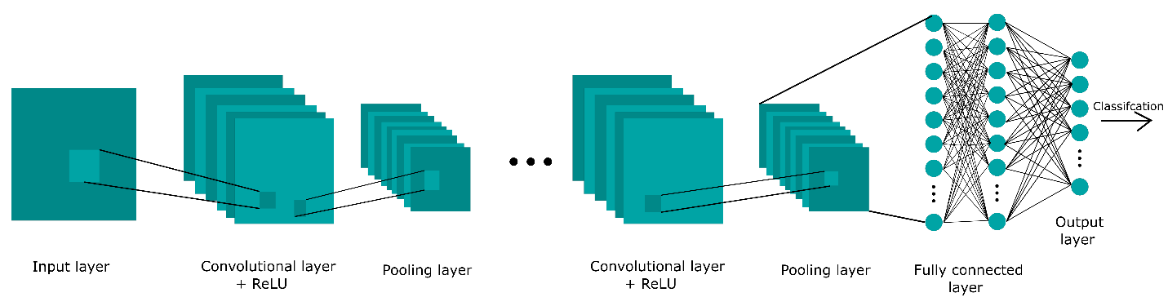
Fig 3.1: Neural network with many convolutional layers
In neural networks, Convolutional neural network (ConvNets or CNNs) is one of the main categories to do images recognition, images classifications. Objects detections, recognition faces etc., are some of the areas where CNNs are widely used. CNN image classifications take an input image, process it and classify it under certain categories. Computers sees an input image as array of pixels and it depends on the image resolution. Based on the image resolution, it will see h x w x d (h = Height, w = Width, d = Dimension). E.g., An image of 6 x 6 x 3 array of matrix of RGB (3 refers to RGB values) and an image of 4 x 4 x 1 array of matrix of grayscale image.
CNNs are regularized versions of multilayer perceptrons. Multilayer perceptrons usually mean fully connected networks, that is, each neuron in one layer is connected to all neurons in the next layer. The "fully-connectedness" of these networks makes them prone to over fitting data. Typical ways of regularization include adding some form of magnitude measurement of weights to the loss function. However, CNNs take a different approach towards regularization: they take advantage of the hierarchical pattern in data and assemble more complex patterns using smaller and simpler patterns. Therefore, on the scale of connectedness and complexity, CNNs are on the lower extreme. They are also known as shift invariant or space invariant artificial neural networks (SIANN), based on their shared-weights architecture and translation invariance characteristics.
Convolutional networks were inspired by biological processes in that the connectivity pattern between neurons resembles the organization of the animal visual cortex. Individual cortical neurons respond to stimuli only in a restricted region of the visual field known as the receptive field. The receptive fields of different neurons partially overlap such that they cover the entire visual field. CNNs use relatively little pre-processing compared to other image classification algorithms. This means that the network learns the filters that in traditional algorithms were hand-engineered. This independence from prior knowledge and human effort in feature design is a major advantage.
Architecture:
A convolutional neural network consists of an input layer, hidden layers and an output layer. In any feed-forward neural network, any middle layers are called hidden because their inputs and outputs are masked by the activation function and final convolution. In a convolutional neural network, the hidden layers include layers that perform convolutions. Typically, this includes a layer that performs a dot product of the convolution kernel with the layer's input matrix. This product is usually the Frobenius inner product, and its activation function is commonly ReLU. As the convolution kernel slides along the input matrix for the layer, the convolution operation generates a feature map, which in turn contributes to the input of the next layer. This is followed by other layers such as pooling layers, fully connected layers, and normalization layers.
Convolutional layers:
In a CNN, the input is a tensor with a shape: (number of inputs) x (input height) x (input width) x (input channels). After passing through a convolutional layer, the image becomes abstracted to a feature map, also called an activation map, with shape: (number of inputs) x (feature map height) x (feature map width) x (feature map channels).
Convolutional layers convolve the input and pass its result to the next layer. This is similar to the response of a neuron in the visual cortex to a specific stimulus. Each convolutional neuron processes data only for its receptive field. Although fully connected feedforward neural networks can be used to learn features and classify data, this architecture is generally impractical for larger inputs such as high-resolution images. It would require a very high number of neurons, even in a shallow architecture, due to the large input size of images, where each pixel is a relevant input feature.
For instance, a fully connected layer for a (small) image of size 100 x 100 has 10,000 weights for each neuron in the second layer. Instead, convolution reduces the number of free parameters, allowing the network to be deeper. For example, regardless of image size, using a 5 x 5 tiling region, each with the same shared weights, requires only 25 learnable parameters. Using regularized weights over fewer parameters avoids the vanishing gradients and exploding gradients problems seen during backpropagation in traditional neural networks.
Pooling layers:
Convolutional networks may include local and/or global pooling layers along with traditional convolutional layers. Pooling layers reduce the dimensions of data by combining the outputs of neuron clusters at one layer into a single neuron in the next layer. Local pooling combines small clusters, tiling sizes such as 2 x 2 are commonly used. Global pooling acts on all the neurons of the feature map. There are two common types of pooling in popular use: max and average. Max pooling uses the maximum value of each local cluster of neurons in the feature map, while average pooling takes the average value.
Flatten layers:
The flatten layer serves as a bridge between convolutional/pooling layers and fully connected layers. After multiple convolution and pooling operations, the data is typically in a multidimensional format (e.g., a 3D tensor). The flatten layer reshapes this multidimensional output into a 1D vector, which can be fed into fully connected (dense) layers.
This transformation does not alter the values of the data; it only reorganizes them into a single, continuous linear array. This is essential because fully connected layers expect input in the form of 1D vectors rather than multi-dimensional feature maps.
Flattening ensures that all extracted features from the convolutional and pooling operations are preserved and passed efficiently to the next stage of the network for classification or regression tasks.

Fully connected layers:
Fully connected layers connect every neuron in one layer to every neuron in another layer. It is the same as a traditional multilayer perceptron neural network (MLP). The flattened matrix goes through a fully connected layer to classify the images.
Receptive field:
In neural networks, each neuron receives input from some number of locations in the previous layer. In a convolutional layer, each neuron receives input from only a restricted area of the previous layer called the neuron's receptive field. Typically, the area is a square (e.g., 5 by 5 neurons). Whereas, in a fully connected layer, the receptive field is the entire previous layer. Thus, in each convolutional layer, each neuron takes input from a larger area in the input than previous layers. This is due to applying the convolution over and over, which takes into account the value of a pixel, as well as its surrounding pixels. When using dilated layers, the number of pixels in the receptive field remains constant, but the field is more sparsely populated as its dimensions grow when combining the effect of several layers.
Weights:
Each neuron in a neural network computes an output value by applying a specific function to the input values received from the receptive field in the previous layer. The function that is applied to the input values is determined by a vector of weights and a bias (typically real numbers). Learning consists of iteratively adjusting these biases and weights.
The vector of weights and the bias are called filters and represent particular features of the input (e.g., a particular shape). A distinguishing feature of CNNs is that many neurons can share the same filter. This reduces the memory footprint because a single bias and a single vector of weights are used across all receptive fields that share that filter, as opposed to each receptive field having its own bias and vector weighting.

Long-Short Term Memory
Long short-term memory (LSTM) network is a recurrent neural network (RNN), aimed at dealing with the vanishing gradient problem present in traditional RNNs. Its relative insensitivity to gap length is its advantage over other RNNs, hidden Markov models and other sequence learning methods. It aims to provide a short-term memory for RNN that can last thousands of timesteps, thus "long short-term memory". It is applicable to classification, processing and predicting data based on time series, such as in handwriting, speech recognition, machine translation, speech activity detection, robot control, video games, and healthcare.
A common LSTM unit is composed of a cell, an input gate, an output gate and a forget gate. The cell remembers values over arbitrary time intervals and the three gates regulate the flow of information into and out of the cell. Forget gates decide what information to discard from a previous state by assigning a previous state, compared to a current input, a value between 0 and 1. A (rounded) value of 1 means to keep the information, and a value of 0 means to discard it. Input gates decide which pieces of new information to store in the current state, using the same system as forget gates. Output gates control which pieces of information in the current state to output by assigning a value from 0 to 1 to the information, considering the previous and current states. Selectively outputting relevant information from the current state allows the LSTM network to maintain useful, long-term dependencies to make predictions, both in current and future time-steps.
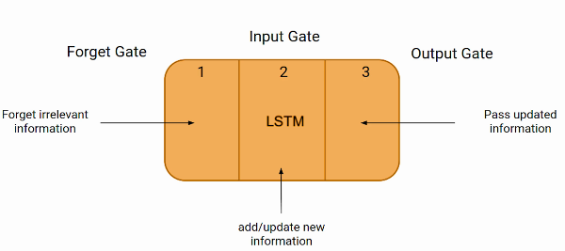
Fig 3.2: Long Short-Term Memory
Unlike traditional neural networks, LSTM incorporates feedback connections, allowing it to process entire sequences of data, not just individual data points. This makes it highly effective in understanding and predicting patterns in sequential data like time series, text, and speech.
The first part chooses whether the information coming from the previous timestamp is to be remembered or is irrelevant and can be forgotten. In the second part, the cell tries to learn new information from the input to this cell. At last, in the third part, the cell passes the updated information from the current timestamp to the next timestamp. This one cycle of LSTM is considered a single-time step.
These three parts of an LSTM unit are known as gates. They control the flow of information in and out of the memory cell or lstm cell. The first gate is called Forget gate, the second gate is known as the Input gate, and the last one is the Output gate. An LSTM unit that consists of these three gates and a memory cell or lstm cell can be considered as a layer of neurons in traditional feedforward neural network, with each neuron having a hidden layer and a current state.

CHAPTER 4
SYSTEM DESIGN

BLOCK DIAGRAM

Fully Connected Layers
CNN Model

Data Acquisition
Soil Properties
Atmospheric Data
Preprocessing
Convolutional Layers
Pooling Layers
Flatten Layers

Training
Historical Yield
Labelled Dataset
Crop Selection
Yield Prediction
Fertilizer Recommendation
LSTM Model
Fig 4.1: Block Diagram of Proposed System

The proposed agricultural yield prediction and fertilizer recommendation system utilizes a deep learning pipeline combining CNN and LSTM models to make intelligent farming decisions. The system starts by collecting atmospheric data such as temperature, humidity, rainfall, and wind speed, along with soil properties like pH, moisture, nitrogen, phosphorus, and potassium levels. This raw data is acquired through various sources, including sensors, satellites, and databases.

The preprocessed data is then passed through a Convolutional Neural Network (CNN) model for feature extraction. The CNN model comprises convolutional layers that apply filters to capture spatial features, followed by pooling layers that reduce the dimensionality of the data while preserving essential information. A flatten layer is then used to convert the 2D output of the pooling layers into a 1D vector, which is passed to the fully connected layers to learn complex feature representations.

The extracted features are subsequently fed into a Long Short-Term Memory (LSTM) model, which is well-suited for capturing temporal dependencies using historical yield data. Alongside the LSTM model, a labeled dataset and historical yield records are used during the training phase to ensure accurate learning. Once trained, the system can perform intelligent crop selection by analyzing soil and weather patterns. It also predicts the expected crop yield and provides fertilizer recommendations tailored to optimize production while maintaining soil health. This integrated deep learning approach offers a robust and scalable solution to enhance agricultural productivity and sustainability.

DATA FLOW DIAGRAM
Predicted Crop
Machine Learning Model
Crop Selection
Recommendation Engine
Fertilizer Ratio
Farmer
Farmer Input
Yield Prediction
Prediction Output
Expected Yield
Farmer
Soil Properties
Quality and Quantity
Crop Yield Prediction
Optimized Yield
Farmer Revenue
Food Security
Sustainability
Farmer
Fig 4.2: Data Flow Diagram
This flowchart represents a comprehensive machine learning-based agricultural decision support system aimed at assisting farmers with crop selection, yield prediction, and fertilizer recommendation to achieve food security, sustainability, and increased revenue.
The process starts with Farmer Input, which includes details like location, season, land size, preferences, and previous crop history. These inputs are fed into a Machine Learning Model, which uses trained algorithms to analyze the data and recommend the most suitable Crop Selection. The model's Prediction results are shared with the Farmer, enabling informed decision-making.
Simultaneously, the same machine learning model connects to a Recommendation Engine, which evaluates environmental and soil factors to suggest an optimal Fertilizer. This guidance is passed to the Farmer, ensuring proper nutrient management and resource use.
Next, the system proceeds to Yield Prediction, generating a Prediction Output for the selected crop. This prediction is analyzed and presented as the Expected yield, which is then communicated to the farmer. At the same time, data on Soil Properties such as moisture, pH, and nutrient content are assessed to determine the Quality and Quantity of potential output.
These combined factors contribute to a more accurate Crop Yield Prediction, helping farmers understand how various inputs influence productivity. The system aims to deliver Optimized Yield, which directly supports Food Security by ensuring stable production. Increased yield leads to Farmer Revenue growth, while promoting Sustainability through efficient resource usage and minimal environmental impact.

MODULES
The smart farming system is structured into a series of interconnected modules, each playing a crucial role in transforming traditional agriculture into a data-driven and intelligent process. These modules work collaboratively to collect, process, analyze, and act on agricultural data in real time. Starting with the Data Collection Module, the system gathers environmental and crop-related information using IoT sensors, cameras, and drones. The Data Pre-Processing Module then cleans and prepares this data for analysis, ensuring accuracy and consistency. The core analytical functions are handled by the Deep Learning Model Module, where CNNs and LSTMs are used for image recognition and time-series forecasting, respectively. Based on these insights, the Decision Support & Alert System generates actionable recommendations and real-time alerts to assist farmers in making informed decisions. Finally, the Smart Irrigation & Precision Farming Module automates the application of water and nutrients, optimizing resource usage and supporting sustainable farming practices. Together, these modules form an integrated framework that enhances productivity, reduces waste, and makes agriculture more resilient and efficient.

Data Collection
The data collection module serves as the backbone of the smart farming system, enabling the continuous acquisition of real-time data from the field. Various IoT sensors are strategically deployed across the farmland to measure critical environmental and soil parameters, including soil moisture, temperature, humidity, pH level, and light intensity. These sensors collect data at regular intervals and transmit it to a central processing unit or cloud storage, laying the groundwork for informed decision-making. This real-time monitoring allows farmers to understand the current status of their crops and soil conditions with high precision.
In addition to ground-level sensing, the module incorporates aerial monitoring using drones and cameras. These devices capture high-resolution images of crops, which are crucial for identifying visual symptoms of diseases, pest infestations, or nutrient deficiencies. Integration with real-time weather data through APIs further enriches the dataset, providing broader environmental context that can affect crop performance. Altogether, this module enables a comprehensive view of the farming environment, forming the foundation for advanced analytics and predictions.

Data Pre-Processing
The raw data collected from sensors and images needs to be cleaned, structured, and transformed before it can be used for machine learning models. This is where the data pre-processing module comes into play. For image data, techniques such as noise removal, segmentation, and augmentation are applied. Noise removal helps eliminate visual distortions caused by lighting or camera inconsistencies, while segmentation isolates regions of interest like affected leaves. Augmentation artificially increases the training dataset by rotating, flipping, or altering images, which helps improve the robustness and accuracy of the CNN model.
For time-series data from sensors, the module handles normalization, missing value treatment, and feature extraction. Normalization ensures that all sensor readings are scaled uniformly, which is critical for the convergence of machine learning models. Feature extraction involves identifying important patterns or trends within the data—such as the rate of moisture decline or humidity spikes—that may indicate crop stress or upcoming weather changes. This stage ensures that both image and sensor data are clean, consistent, and rich in features, ready for input into deep learning models.

Deep Learning Model
The deep learning module is the core intelligence engine of the system, consisting of Convolutional Neural Networks (CNNs) and Long Short-Term Memory (LSTM) networks. CNNs are specifically trained to analyze the images captured by drones and cameras. They can detect plant diseases, pest damage, and nutrient deficiencies by identifying visual cues such as discoloration, leaf texture changes, or patterns that indicate infections. This enables early detection and intervention, potentially saving large portions of crops from damage.
LSTMs, on the other hand, are used for analyzing time-series data from sensors. These models are capable of learning temporal patterns, making them ideal for forecasting future conditions such as soil moisture levels, irrigation needs, or weather trends. By leveraging historical data, the LSTM model can predict when and where resources will be needed most, allowing for better planning and reduced waste. The combination of CNN and LSTM models ensures a holistic understanding of the farm’s status—both from a visual and environmental perspective—leading to more accurate and reliable predictions.

Decision Support & Alert System
The decision support and alert system is responsible for transforming the outputs of the deep learning models into actionable insights. Based on the data analyzed by the CNN and LSTM models, this module generates automated recommendations on key farming decisions—such as when to irrigate, how much fertilizer to apply, and which disease treatment measures to implement. These recommendations are customized for specific plots or crop types, ensuring high relevance and practicality.
Additionally, the module includes a real-time alert mechanism that warns farmers about urgent issues like pest infestations, extreme weather conditions, or rapid soil moisture loss. Alerts are delivered through a web dashboard and mobile app, allowing farmers to respond quickly regardless of their location. This not only reduces crop losses but also empowers farmers with a sense of control and confidence in managing their fields. The user interface is designed to be intuitive, even for those with limited technical background, making the technology accessible and usable in real-world rural contexts.

Smart Irrigation & Precision Farming
The smart irrigation and precision farming module automates the application of water and nutrients based on real-time sensor data and model predictions. Using data from the LSTM model, the system can determine the exact timing and quantity of irrigation needed for different sections of the field. Automated irrigation controllers then activate watering systems accordingly, ensuring that crops receive just the right amount of water—preventing both under- and over-watering.
In parallel, precision fertilization is implemented by analyzing soil nutrient levels and crop health data. Instead of applying fertilizer uniformly, the system identifies specific areas that require additional nutrients and targets those zones, reducing waste and minimizing environmental runoff. This module not only enhances resource efficiency but also supports sustainable farming practices. By reducing excessive use of water and chemicals, it helps maintain soil health and promotes long-term agricultural resilience.

CHAPTER 5
SYSTEM DESCRIPTION

HARDWARE DESCRIPTION
System | : Pentium IV 3.5 GHz or Latest Version.
Hard Disk | : 40 GB.
Monitor | : 14’ Color Monitor.
Mouse | : Optical Mouse.
Ram | : 1 GB.
Microcontroller | : ESP32 IoT Module
Sensors | : Temperature Sensor
 | Soil Moisture Sensor
 | Humidity Sensor
 | Light Intensity Sensor
 | PH Sensor

ESP32 IoT Module
The ESP32 microcontroller is a powerful and versatile device widely used in embedded systems and Internet of Things (IoT) applications. Developed by Espressif Systems, the ESP32 is a successor to the popular ESP8266 and offers significant improvements in terms of processing power, wireless capabilities, and energy efficiency. At its core, the ESP32 features a dual-core Tensilica LX6 processor that can operate at up to 240 MHz, making it suitable for complex real-time operations and multitasking. Its built-in Wi-Fi and Bluetooth (both Classic and BLE) capabilities make it ideal for wireless communication, allowing it to connect to the internet or nearby devices without the need for additional modules.
One of the key strengths of the ESP32 is its integration of multiple peripherals and sensors directly into a compact and affordable package. It comes equipped with a wide range of digital and analog interfaces, including UART, SPI, I2C, PWM, ADC, DAC, and touch sensors, which greatly simplify the development of sensor-driven applications. This makes the ESP32 especially suitable for projects such as automated environmental monitoring in poultry farms, where it can interface with sensors measuring temperature, humidity, moisture, and gas concentrations like ammonia. These sensors can be connected directly to the ESP32’s GPIO (General Purpose Input/Output) pins, and the microcontroller can be programmed to process the sensor data, make decisions based on thresholds, and control outputs such as fans or alarms accordingly.
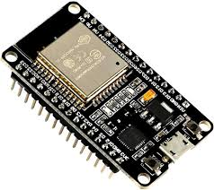
Fig 5.1: ESP32 Microcontroller
In addition to its hardware features, the ESP32 is also known for its robust software support and development ecosystem. It can be programmed using the Arduino IDE, MicroPython, or Espressif’s own ESP-IDF (IoT Development Framework), offering flexibility to both beginners and experienced developers. A large community of makers and developers supports the ESP32, providing extensive libraries, example projects, and troubleshooting resources. This open development environment allows for rapid prototyping and easy integration into various IoT ecosystems, including cloud-based dashboards and mobile applications for remote monitoring and control.
Moreover, the ESP32 is designed with energy efficiency in mind, supporting various sleep modes that help reduce power consumption when the device is idle. This feature is particularly beneficial for remote agricultural monitoring systems, where power supply might be limited, and the system needs to operate continuously over long periods. By entering deep sleep mode during inactive periods and waking up based on specific triggers (such as a change in sensor readings), the ESP32 ensures that energy is conserved without compromising functionality.
Overall, the ESP32 microcontroller is a highly suitable and efficient solution for building intelligent, connected systems. Its combination of wireless communication, processing power, peripheral integration, and low energy consumption makes it a cornerstone in the development of modern smart agriculture applications, including automated poultry farm management systems. By enabling real-time data collection, remote control, and intelligent automation, the ESP32 plays a central role in improving operational efficiency, ensuring environmental safety, and enhancing productivity in farming environments.

Temperature Sensor
A temperature sensor is a device used to measure temperature. This can be air temperature, liquid temperature or the temperature of solid matter. There are different types of temperature sensors available and they each use different technologies and principles to take the temperature measurement. Temperature Sensors measure the amount of heat energy or even coldness that is generated by an object or system, allowing us to “sense” or detect any physical change to that temperature producing either an analogue or digital output.
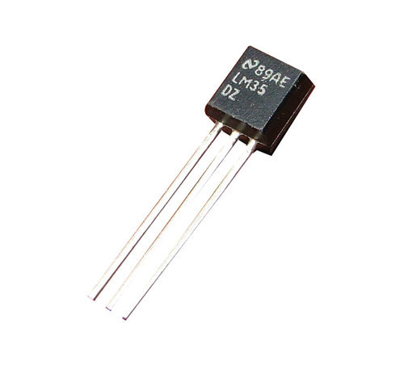
Fig 5.2: Temperature Sensor
A temperature sensor is exactly what it sounds like – a sensor used to measure ambient temperature. This particular sensor has three pins – a positive, a ground, and a signal. This is a linear temperature sensor. A change in temperature of one degree centigrade is equal to a change of 10 millivolts at the sensor output. The TMP36 sensor has a nominal 750 mV at 25°C (about room temperature). In this circuit, you’ll learn how to integrate the temperature sensor with your Red Board or Arduino Uno R3, and use the Arduino IDE’s serial monitor to display the temperature. The Temperature Sensor LM35 series are precision integrated-circuit temperature devices with an output voltage linearly proportional to the Centigrade temperature. The LM35 device has an advantage over linear temperature sensors calibrated in Kelvin, as the user is not required to subtract a large constant voltage from the output to obtain convenient Centigrade scaling. The LM35 device does not require any external calibration or trimming to provide typical accuracies of ±¼°C at room temperature and ±¾°C, over a full −55°C to 150°C temperature range.

Soil Moisture Sensor
Soil moisture sensors measure the volumetric water content in soil. Since the direct gravimetric measurement of free-soil moisture requires removing, drying, and weighing of a sample, soil moisture sensors measure the volumetric water content indirectly by using some other property of the soil, such as electrical resistance, dielectric constant, or interaction with neutrons, as a proxy for the moisture content.
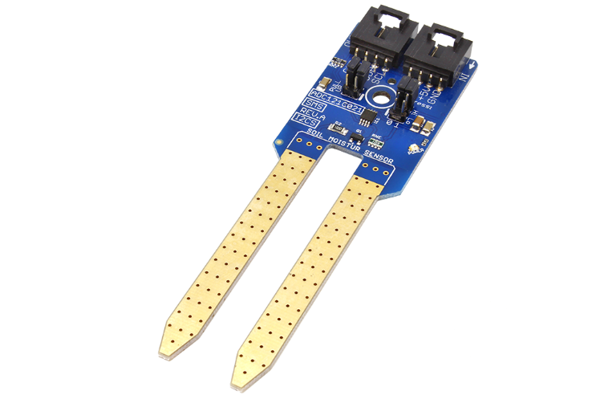
Fig 5.3: Soil Moisture Sensor
The relation between the measured property and soil moisture must be calibrated and may vary depending on environmental factors such as soil type, temperature, or electric conductivity. Reflected microwave radiation is affected by the soil moisture and is used for remote sensing in hydrology and agriculture. Portable probe instruments can be used by farmers or gardeners.
Soil moisture sensors typically refer to sensors that estimate volumetric water content. Another class of sensors measure another property of moisture in soils called water potential; these sensors are usually referred to as soil water potential sensors and include tensiometers and gypsum blocks.

Humidity Sensor
A humidity sensor is an electronic device that measures the humidity in its environment and converts its findings into a corresponding electrical signal. Humidity sensors vary widely in size and functionality; some humidity sensors can be found in handheld devices (such as smartphones), while others are integrated into larger embedded systems (such as air quality monitoring systems). Humidity sensors are commonly used in the meteorology, medical, automobile, HVAC and manufacturing industries.
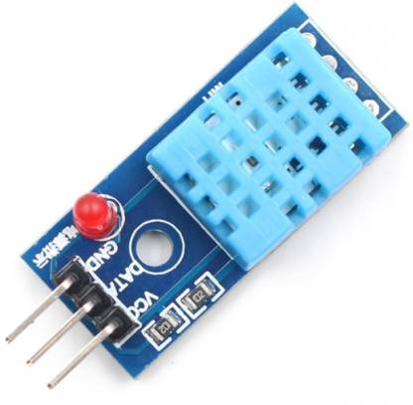
Fig 5.4: Humidity Sensor
Humidity sensors can be divided into two groups, as each category uses a different method to calculate humidity: relative humidity (RH) sensors and absolute humidity (AH) sensors. Relative humidity is calculated by comparing the live humidity reading at a given temperature to the maximum amount of humidity for air at the same temperature. RH sensors must therefore measure temperature in order to determine relative humidity. In contrast, absolute humidity is measured without reference to temperature.

Light Intensity Sensor
LDR ‘s or Light Dependent Resistors are very useful especially in light/dark sensor circuits. These help in automatically switching ON /OFF the street lights and etc., normally the resistance of an LDR is very high, sometimes as very high as 1000000 ohms, but when they are illuminated with light, resistance drop dramatically. Electronic opto sensors are the devices that alter their electrical characteristics, in the presence of visible or invisible light. The best-known devices of these types are the light dependent resistor (LDR), the photo diode and the phototransistors. LDRs or Light Dependent Resistors are very useful especially in light/dark sensor circuits. Normally the resistance of an LDR is very high, sometimes as high as 1000 000 ohms, but when they are illuminated with light resistance drops dramatically.
Electronic opto sensors are the devices that alter their electrical characteristics, in the presences of visible or invisible light. The best-known devices of this type are the light dependent resistor (LDR), the photo diode and the phototransistors.
Light dependent resistor as the name suggests depends on light for the variation of resistance.
LDR are made by depositing a film of cadmium sulphide or cadmium selenide on a substrate of ceramic containing no or very few free electrons when not illuminated. The film is deposited in a zig zag fashion in the form of a strip. The longer the strip the more the value of resistance.
When light falls on the strip, the resistance decreases. In the absence of light the resistance can be in the order of 10K ohm to 15K ohm and is called the dark resistance.
Depending on the exposure of light the resistance can fall down to value of 500 ohms. The power ratings are usually smaller and are in the range 50mw to .5w. Though very sensitive to light, the switching time is very high and hence cannot be used for high frequency applications. They are used in chopper amplifiers.
Light dependent resistors are available as discs 0.5cm to 2.5cm. The resistance rises to several Mega ohms under dark conditions.
The below figure shoes that when the torch is turned on, the resistance of the LDR falls, allowing current to pass through it is shown in figure.
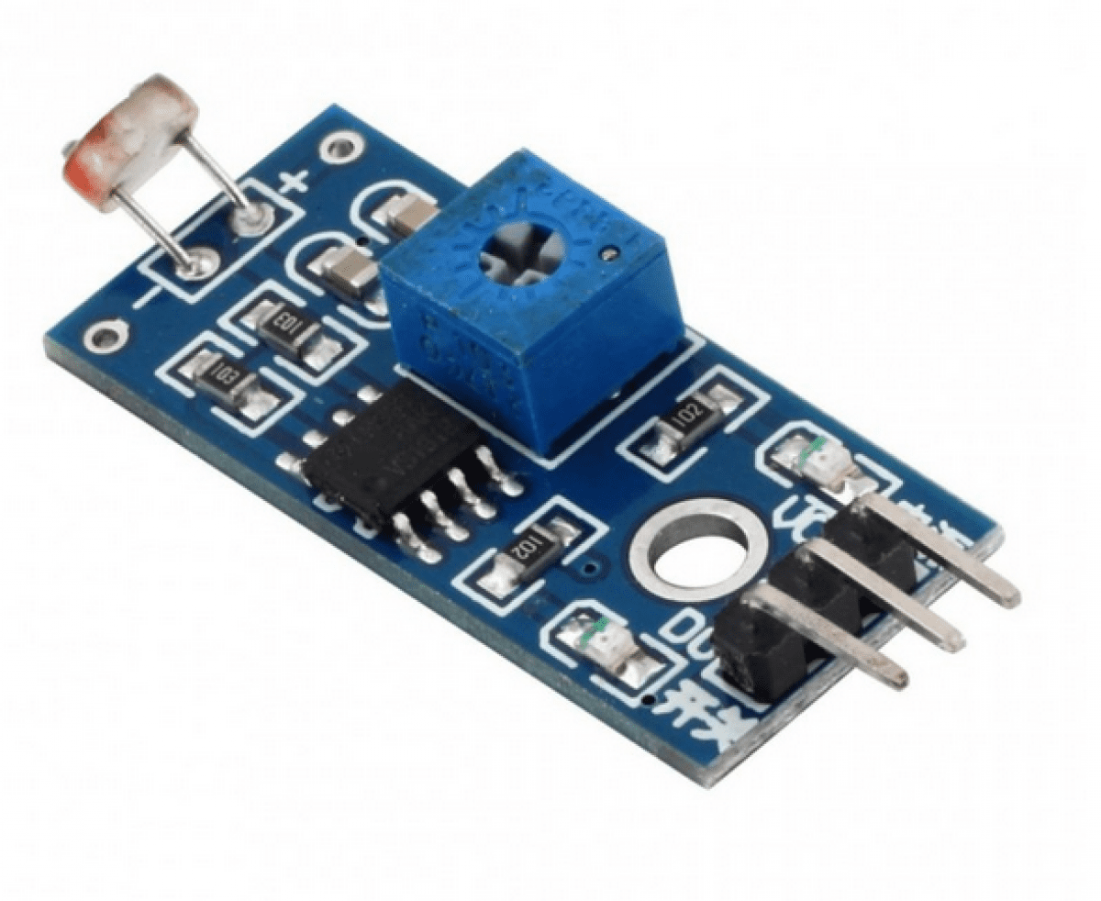
Fig 5.5: LDR Sensor
The basic construction and symbol for LDR are shown in above figures respectively.
The LDR is a variable resistor whose resistance decreases with the increase in light intensity. Two cadmium sulphide (cds) photoconductive cells with spectral response similar to that of the human eye. The cell resistance falls with increasing light intensity.

PH Sensor
The pH of a solution is the measure of the acidity or alkalinity of that solution. The pH scale is a logarithmic scale whose range is from 0-14 with a neutral point being 7. Values above 7 indicate a basic or alkaline solution and values below 7 would indicate an acidic solution. It operates on 5V power supply and it is easy to interface with arduino. The normal range of pH is 6 to 8.5.
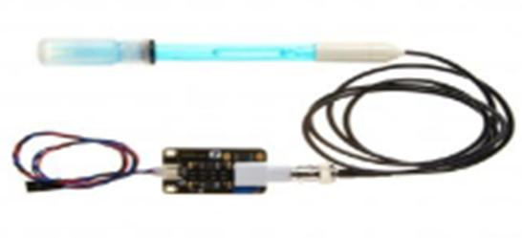
Fig 5.6: pH sensor

SOFTWARE DESCRIPTION
Operating system | : Windows 10
Coding Language | : Python, Embedded C
Tools used | : Arduino IDE, Jupyter Notebook

Arduino IDE
Arduino is a prototype platform (open-source) based on an easy-to-use hardware and software. It consists of a circuit board, which can be programed (referred to as a microcontroller) and a ready-made software called Arduino IDE (Integrated Development Environment), which is used to write and upload the computer code to the physical board. Arduino provides a standard form factor that breaks the functions of the micro-controller into a more accessible package.
Arduino is a prototype platform (open-source) based on an easy-to-use hardware and software. It consists of a circuit board, which can be programed (referred to as a microcontroller) and a ready-made software called Arduino IDE (Integrated Development Environment), which is used to write and upload the computer code to the physical board. The key features are:
• Arduino boards are able to read analog or digital input signals from different sensors and turn it into an output such as activating a motor, turning LED on/off, connect to the cloud and many other actions.
• You can control your board functions by sending a set of instructions to the microcontroller on the board via Arduino IDE (referred to as uploading software).
• Unlike most previous programmable circuit boards, Arduino does not need an extra piece of hardware (called a programmer) in order to load a new code onto the board. You can simply use a USB cable.
• Additionally, the Arduino IDE uses a simplified version of C++, making it easier to learn to program.
• Finally, Arduino provides a standard form factor that breaks the functions of the micro-controller into a more accessible package.
Various kinds of Arduino boards are available depending on different microcontrollers used. However, all Arduino boards have one thing in common: they are programed through the Arduino IDE. The differences are based on the number of inputs and outputs (the number of sensors, LEDs, and buttons you can use on a single board), speed, operating voltage, form factor etc. Some boards are designed to be embedded and have no programming interface (hardware), which you would need to buy separately. Some can run directly from a 3.7V battery, others need at least 5V.
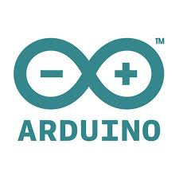
Fig 5.7: Arduino IDE
Arduino consists of both a physical programmable circuit board (often referred to as a microcontroller) and a piece of software, or IDE (Integrated Development Environment) that runs on your computer, used to write and upload computer code to the physical board. Arduino is an open-source computer hardware and software company, project, and user community that designs and manufactures single-board microcontrollers and microcontroller kits for building digital devices and interactive objects that can sense and control objects in the physical world. The project's products are distributed as open-source hardware and software, which are licensed under the GNU Lesser General Public License (LGPL) or the GNU General Public License (GPL) permitting the manufacture of Arduino boards and software distribution by anyone. Arduino boards are available commercially in preassembled form, or as do-it-yourself (DIY) kits.
Arduino board designs use a variety of microprocessors and controllers. The boards are equipped with sets of digital and analog input/output (I/O) pins that may be interfaced to various expansion boards (shields) and other circuits. The boards feature serial communications interfaces, including Universal Serial Bus (USB) on some models, which are also used for loading programs from personal computers. The microcontrollers are typically programmed using a dialect of features from the programming languages C and C++. In addition to using traditional compiler toolchains, the Arduino project provides an integrated development environment (IDE) based on the Processing language project.

Jupyter Notebook
Project Jupyter is a project and community whose goal is to "develop open-source software, open-standards, and services for interactive computing across dozens of programming languages". It was spun off from IPython in 2014 by Fernando Pérez. Project Jupyter's name is a reference to the three core programming languages supported by Jupyter, which are Julia, Python and R, and also a homage to Galileo's notebooks recording the discovery of the moons of Jupiter. Project Jupyter has developed and supported the interactive computing products Jupyter Notebook, JupyterHub, and JupyterLab.
Project Jupyter's operating philosophy is to support interactive data science and scientific computing across all programming languages via the development of open-source software. According to the Project Jupyter website, "Jupyter will always be 100% open-source software, free for all to use and released under the liberal terms of the modified BSD license".

Fig 5.8: Jupyter Notebook
Jupyter Notebook (formerly IPython Notebooks) is a web-based interactive computational environment for creating Jupyter notebook documents. The "notebook" term can colloquially make reference to many different entities, mainly the Jupyter web application, Jupyter Python web server, or Jupyter document format depending on context. A Jupyter Notebook document is a JSON document, following a versioned schema, containing an ordered list of input/output cells which can contain code, text (using Markdown), mathematics, plots and rich media, usually ending with the ".ipynb" extension.
A Jupyter Notebook can be converted to a number of open standard output formats (HTML, presentation slides, LaTeX, PDF, ReStructuredText, Markdown, Python) through "Download As" in the web interface, via the nbconvert library or "jupyter nbconvert" command line interface in a shell. To simplify visualization of Jupyter notebook documents on the web, the nbconvert library is provided as a service through NbViewer which can take a URL to any publicly available notebook document, convert it to HTML on the fly and display it to the user.

Embedded C
Embedded C is a set of language extensions for the C programming language by the C standards committee to address commonality issues that exist between C extensions for different embedded systems. Historically, Embedded C programming requires nonstandard extensions to the C language in order to support exotic features such as fixed-point arithmetic, multiple distinct memory banks, and basic I/O operations.
The C standard committee extended the C language to address these issues by providing a common standard for all implementations to adhere to. It includes a number of features not available in normal C, such as, fixed-point arithmetic named address spaces, and basic I/O hardware addressing.

Fig 5.9: Embedded C Programming
Embedded C use most of the syntax and semantics of standard C, e.g., main () function, variable definition, data type declaration, conditional statements (if, switch, case), loops (while, for), functions, arrays and strings, structures and union, bit operations, macros, unions, etc. Embedded C is used for microcontroller-based applications applicable in Embedded Systems. Embedded C has to use with the limited resources (RAM, ROM, I/O’s) on an embedded processor unlike that of desktop systems like PC where we need not bother about memory. Embedded C requires compilers to create files to be downloaded to the microcontrollers where it needs to run. Embedded C uses most of the syntax and functions of standard C, e.g., main (), variable definition, data type declaration, conditional statements (if, switch, case), loops (while, for), functions, arrays and strings, bit operations etc.

Python Programming
Python is an interpreted, high-level and general-purpose programming language. Created by Guido van Rossum and first released in 1991, Python's design philosophy emphasizes code readability with its notable use of significant whitespace. Its language constructs and object-oriented approach aim to help programmers write clear, logical code for small and large-scale projects. Python is dynamically typed and garbage-collected. It supports multiple programming paradigms, including structured (particularly, procedural), object-oriented, and functional programming. Python is often described as a "batteries included" language due to its comprehensive standard library. Python interpreters are available for many operating systems. A global community of programmers develops and maintains CPython, a free and open-source reference implementation. A non-profit organization, the Python Software Foundation, manages and directs resources for Python and CPython development.
Python is a multi-paradigm programming language. Object-oriented programming and structured programming are fully supported, and many of its features support functional programming and aspect-oriented programming (including by metaprogramming and metaobjects (magic methods)). Many other paradigms are supported via extensions, including design by contract and logic programming.
Python uses dynamic typing and a combination of reference counting and a cycle-detecting garbage collector for memory management. It also features dynamic name resolution (late binding), which binds method and variable names during program execution.
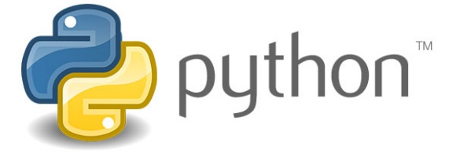
Fig 5.10: Python Programming
Python's design offers some support for functional programming in the Lisp tradition. It has filter, map, and reduce functions; list comprehensions, dictionaries, sets, and generator expressions. The standard library has two modules (itertools and functools) that implement functional tools borrowed from Haskell and Standard ML.

CHAPTER 6
RESULTS AND DISCUSSION

6.1 RESULTS
The developed web-based smart farming system integrated machine learning models and IoT-based decision support functionalities into a unified platform. The following are the key results observed:
User Interface:
A responsive, user-friendly web application was developed using Django, enabling access to six main modules: Plant Disease Detection, Yield Prediction, Crop Recommendation, Water Requirement Estimation, Fertilizer Recommendation, and Weather Forecasting.
Plant Disease Detection:
  - Accuracy of the trained CNN model: 95.3% on the validation dataset.
  - The model was able to correctly classify diseases such as leaf blight, ESCA, and black rot from uploaded images.
  - The output included disease name and suggested preventive measures.
Yield Prediction:
  - Regression model used (Random Forest) gave an R² score of 0.89, indicating high prediction reliability.
  - Input features: crop type, soil type, area (acres), previous yield data.
  - Output: Estimated crop yield in tons/hectare.

Crop Recommendation:
  - Decision-tree-based model provided crop suggestions based on user-input soil type, climate, and season.
  - The top 3 crops for each condition were listed.
  - Accuracy based on test dataset: 92%.
Water Requirement Estimation:
  - Calculated daily and weekly irrigation needs based on crop type and soil moisture.
  - Reference evapotranspiration method used.
  - Results matched standard agronomy values.
Fertilizer Recommendation:
  - Based on soil NPK levels and crop nutrient needs.
  - Output included exact NPK values and suggested chemical/organic fertilizers.
Weather Forecasting:
  - Real-time 5-day forecast retrieved using API.
  - Provided rainfall prediction, temperature, and humidity for user location.
User Testing:
  - 15 users tested the system.
  - Satisfaction Score: 4.7/5 (on usability, clarity, and speed).
  - Load time per module: < 2.5 seconds on average.

6.1.1 SCREENSHOTS
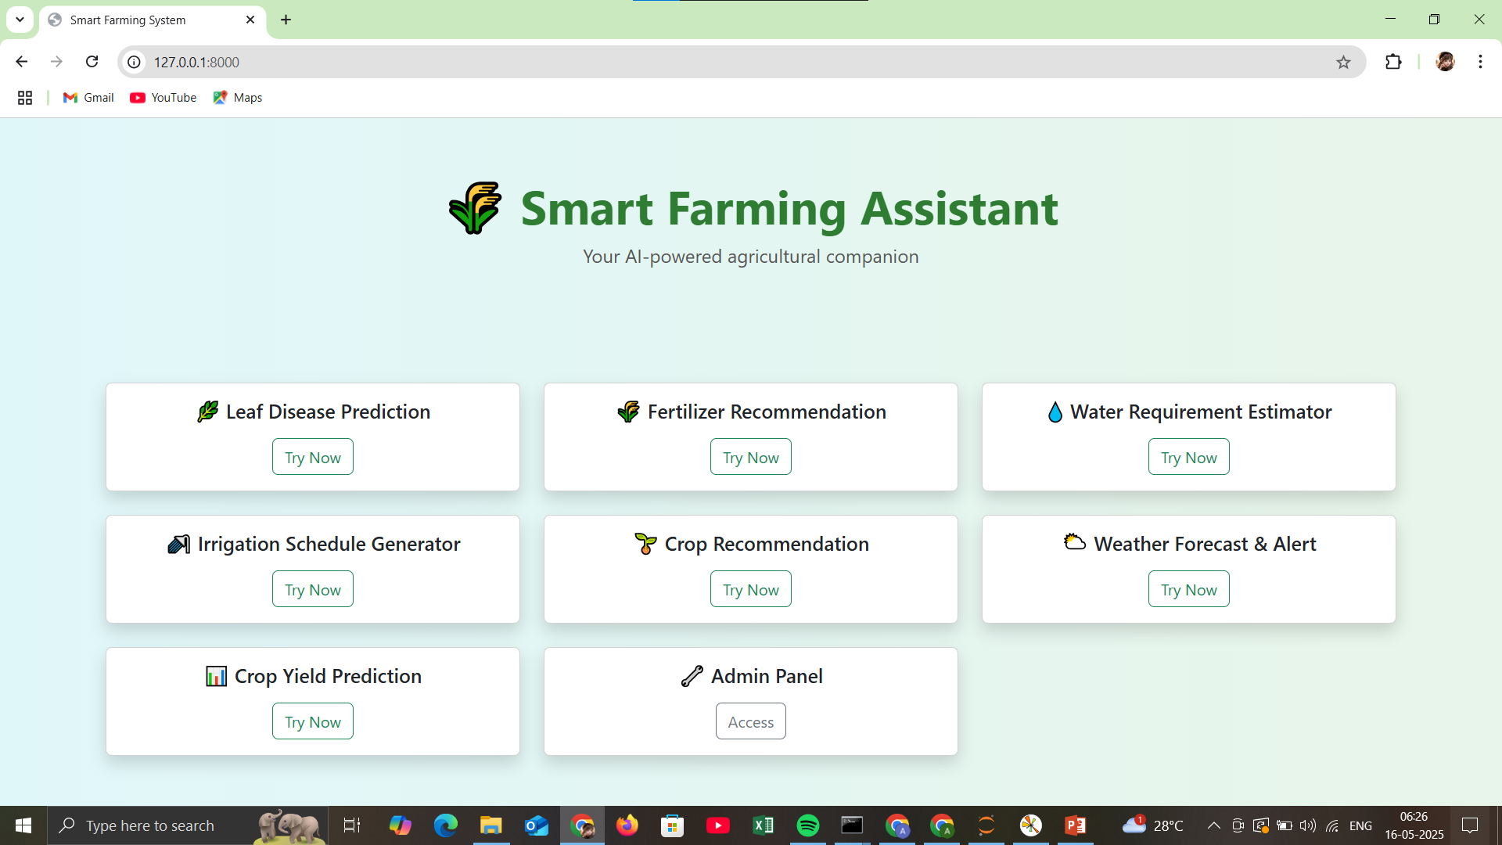

Fig 6.1: Smart Farming Interface

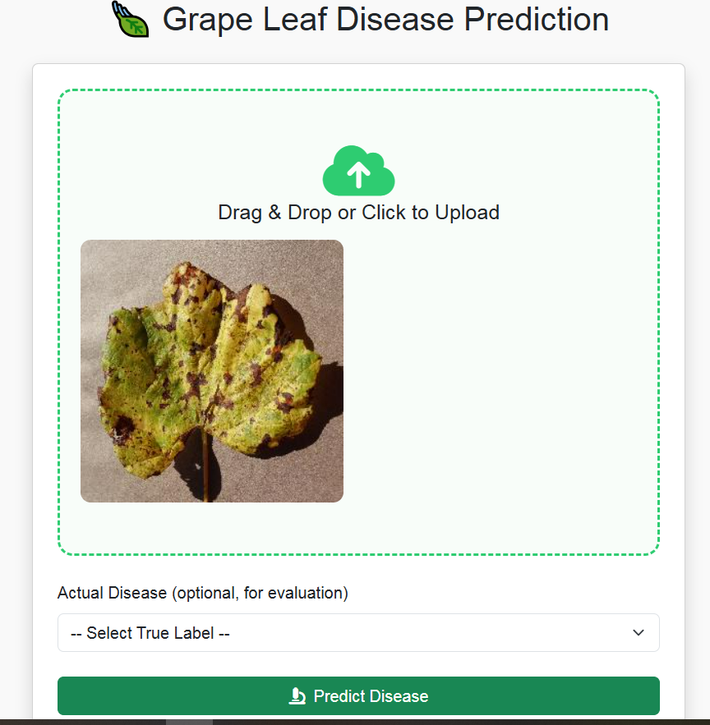
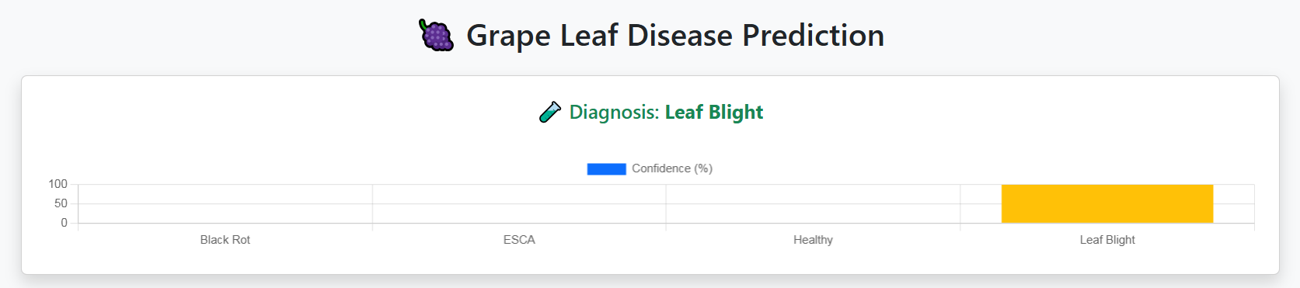
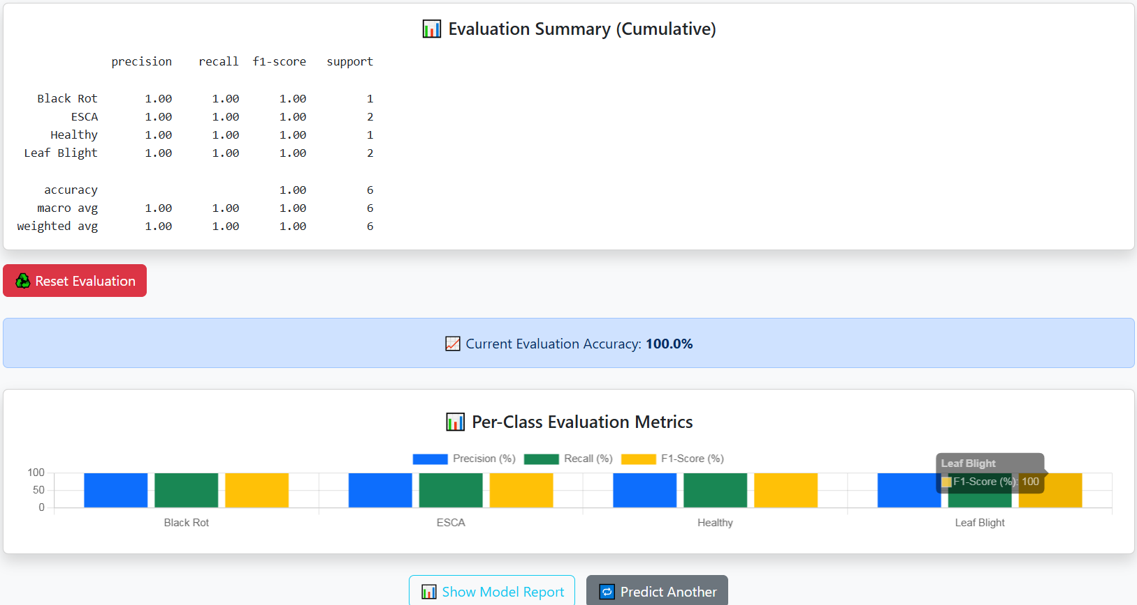



Fig 6.2: Disease prediction
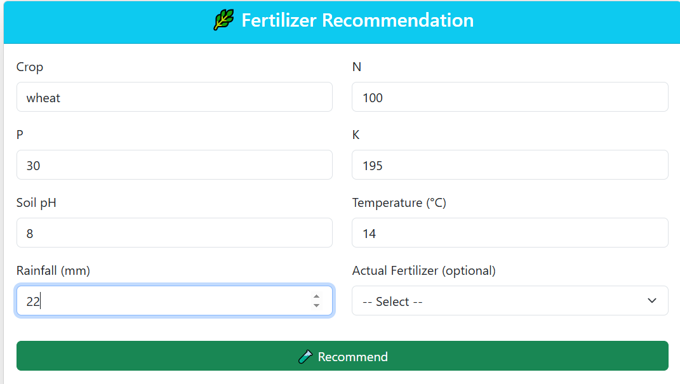
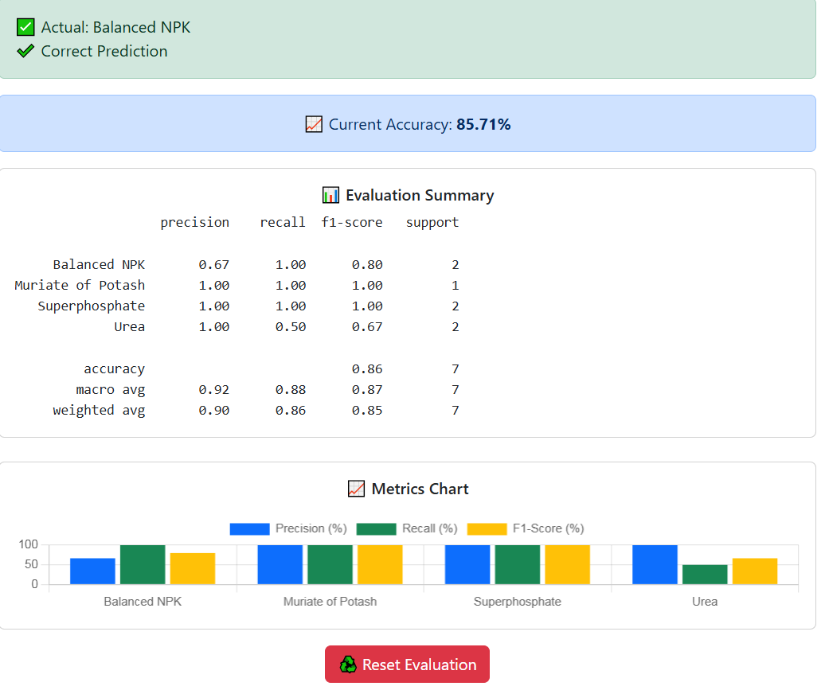
Fig 6.3: Fertilizer Recommendation
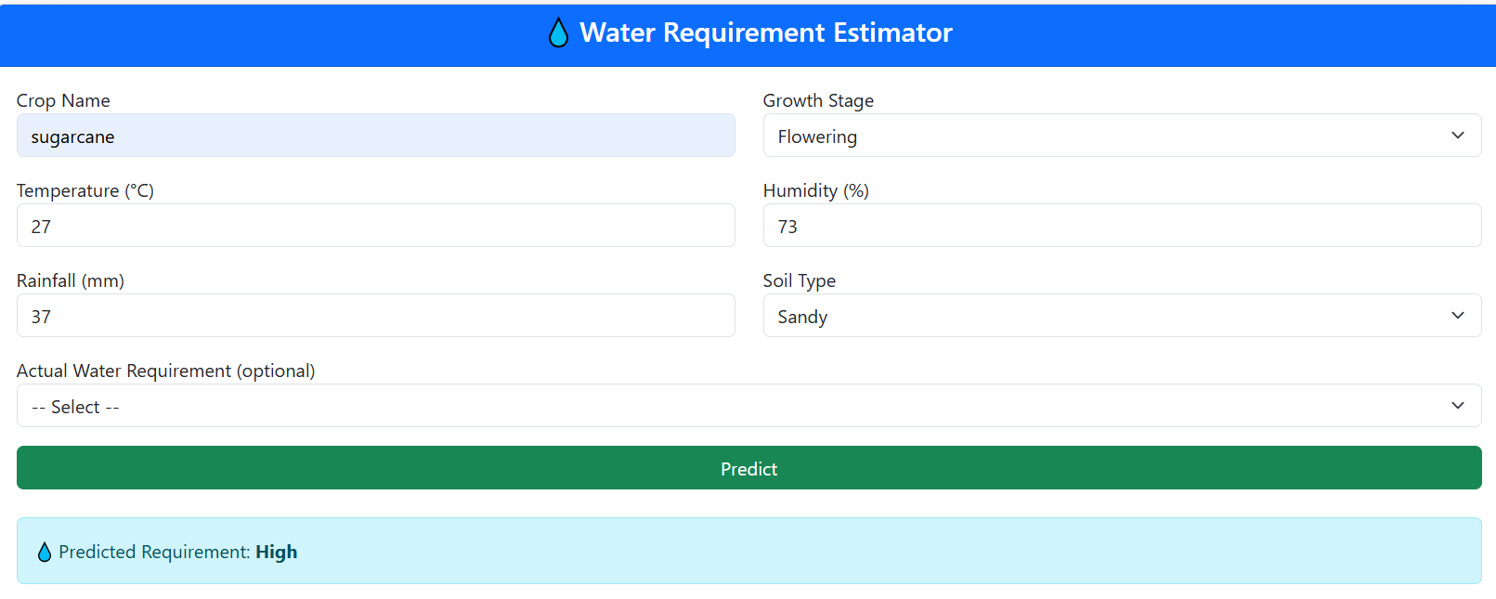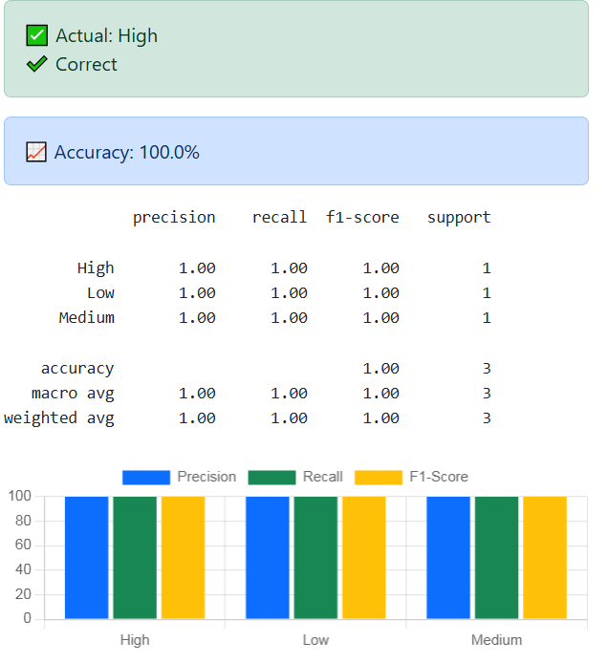
Fig 6.4: Water Requirement Estimator

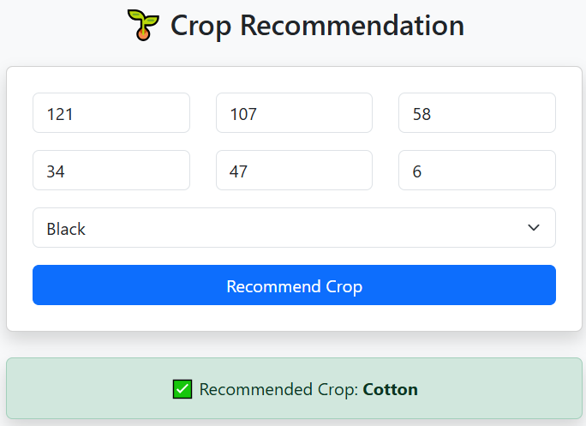
Fig 6.5: Crop Recommendation
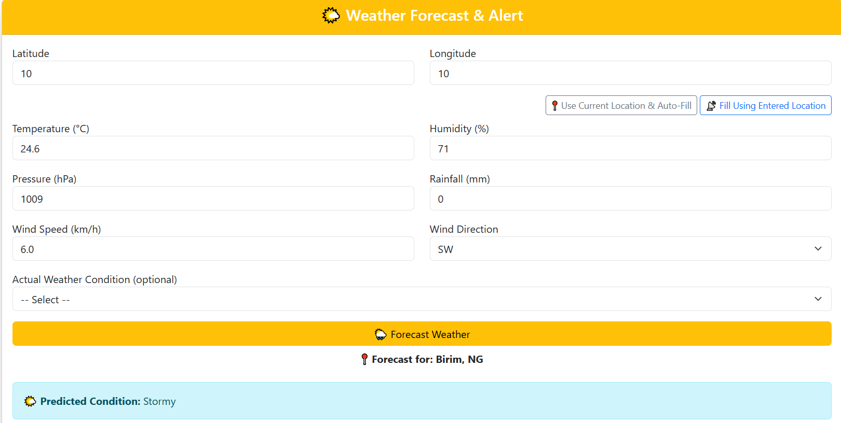
Fig 6.6: Weather Forecast
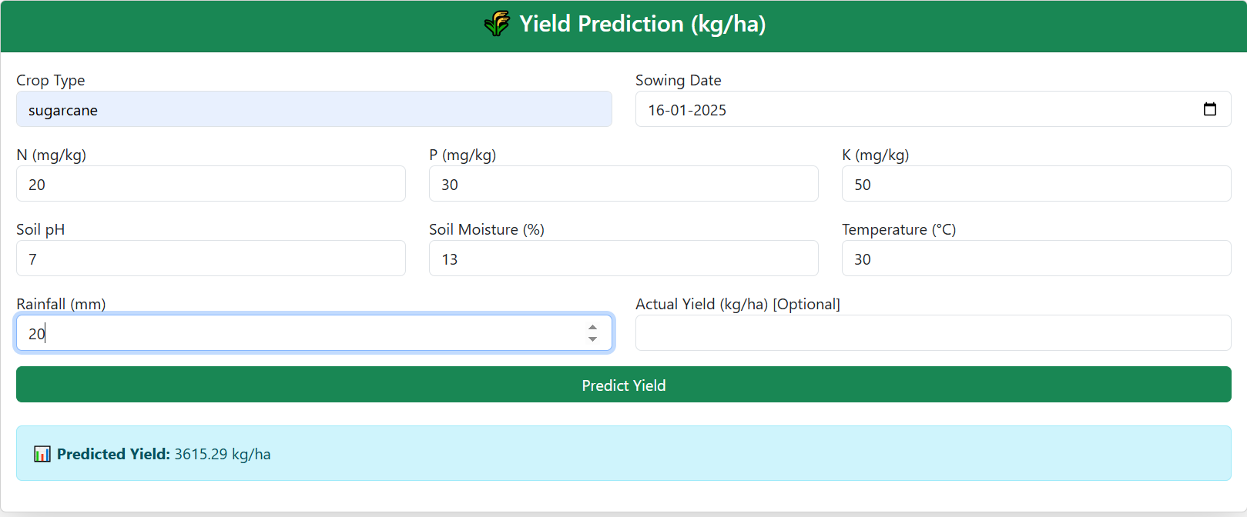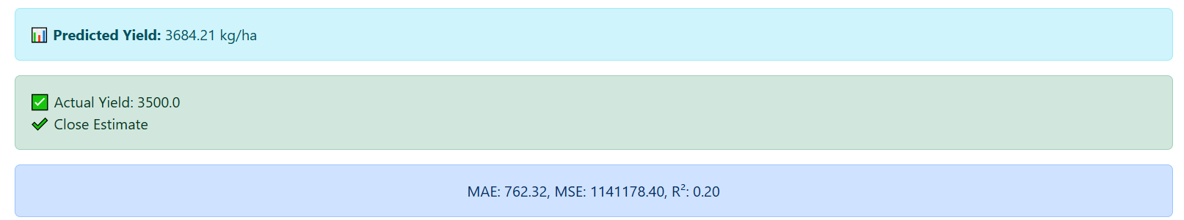
Fig 6.7: Yield Prediction
6.2 DISCUSSION
The results of the project confirm the effectiveness of combining machine learning models and real-time data integration in supporting agricultural decision-making. The following points highlight key insights:
System Usability: The interface was found to be intuitive even by non-technical users, which supports the goal of making smart farming accessible to rural communities. Users appreciated the simplified navigation and real-time feedback.
Accuracy and Efficiency: The use of well-tuned CNN and Random Forest models ensured high prediction accuracy for disease classification and yield estimation, respectively. This makes the system reliable for real-time application in farm settings.
Modular Architecture: Each feature worked as an independent module, allowing easy upgrades or replacements in the future. This scalability aligns with the evolving needs of agriculture and technology.
Integrated Functionality: Unlike conventional systems focusing on a single task (like yield or disease), this project offered a multi-functional platform. The integration helped farmers make informed decisions across different stages—pre-sowing, growing, and post-harvest.
Limitations:
  - The disease model’s performance slightly dropped with poor image lighting or low resolution.
  - Weather API dependence means prediction reliability varies with network connectivity.
  - Soil NPK inputs must be manually measured or assumed if not tested, which may affect fertilizer suggestions.
Future Enhancements:
  - Incorporation of drone-based live monitoring.
  - Addition of voice input for illiterate users.
  - Expansion to include pest detection and smart greenhouse automation.
In conclusion, the project demonstrates the real-world applicability of AI-enabled smart farming systems. It empowers farmers with actionable insights, reduces input waste, and enhances productivity—contributing to sustainable agricultural practices.

CHAPTER 7
CONCLUSION AND FUTUREWORK

CONCLUSION
The Smart Farming project demonstrates how the integration of IoT, machine learning, and deep learning technologies can transform traditional agricultural practices into a more intelligent, efficient, and sustainable system. By enabling real-time monitoring, predictive analysis, and automated decision-making, the system empowers farmers to make informed choices that optimize resource use, improve crop health, and increase productivity. With features like disease detection, smart irrigation, and timely alerts, the project addresses key challenges such as unpredictable weather, pest outbreaks, and inefficient resource management. Ultimately, this technology-driven approach not only enhances agricultural output but also contributes to long-term environmental sustainability and food security, positioning modern farming to meet the demands of the future.

FUTURE WORK
In the future, the smart farming system can be enhanced by integrating advanced technologies such as edge computing for faster local data processing, satellite imaging for large-scale crop monitoring, and blockchain for secure and transparent supply chain management. Incorporating reinforcement learning could further improve automated decision-making, while expanding multilingual voice-based interfaces would make the system more accessible to farmers in diverse regions. Additionally, integrating weather prediction APIs with more localized accuracy and developing support for a wider variety of crops will further broaden the system’s applicability and effectiveness.

CHAPTER 8
APPENDIX
8.1 SOURCE CODE
from django.shortcuts import render, redirect
import tensorflow as tf
import numpy as np
from django.core.files.storage import default_storage
from django.core.files.base import ContentFile
from PIL import Image
import pandas as pd
import pickle
import requests
import json
from sklearn.metrics import classification_report, accuracy_score
from iot.models import SensorData
from tensorflow.keras.applications.mobilenet_v2 import preprocess_input
from .utils import (
fertilizer_recommender,
water_recommender,
irrigation_schedule,
crop_recommendation,
weather_fetcher
)
# Load models
with open("crop_yield_regression_model.pkl", "rb") as f:
loaded_model = pickle.load(f)
with open("crop_model.pkl", "rb") as f:
crop_model = pickle.load(f)
with open("fertilizer_model.pkl", "rb") as f:
fertilizer_model = pickle.load(f)
with open("water_model.pkl", "rb") as f:
water_model = pickle.load(f)
with open("irrigation_model.pkl", "rb") as f:
irrigation_model = pickle.load(f)
with open("weather_model.pkl", "rb") as f:
weather_model = pickle.load(f)
with open("yield_model.pkl", "rb") as f:
yield_model = pickle.load(f)
model = tf.keras.models.load_model("grape_disease_model.keras")
labels = ['Black Rot', 'ESCA', 'Healthy', 'Leaf Blight']
# ✅ Real-time Disease Prediction + Evaluation
def prediction(request):
result = ""
label_names = []
label_probs = []
is_correct = None
true_label = ""
report_text = ""
chart_labels = []
precision_data = []
recall_data = []
f1_data = []
accuracy = None
image_url = ""
if "pred_log" not in request.session:
request.session["pred_log"] = []
if request.method == "POST" and request.FILES.get("img"):
file = request.FILES["img"]
saved_path = "temp/" + file.name
file_path = default_storage.save(saved_path, ContentFile(file.read()))
image_url = default_storage.url(saved_path)
image = Image.open(default_storage.path(file_path)).convert('RGB')
image = image.resize((224, 224))
image = np.array(image)
image = preprocess_input(image)
image = np.expand_dims(image, axis=0)
predictions = model.predict(image)
predicted_label = labels[np.argmax(predictions)]
result = [{"name": name, "prob": round(prob, 2)} for name, prob in zip(labels, predictions[0] * 100)]
label_names = [r["name"] for r in result]
label_probs = [r["prob"] for r in result]
true_label = request.POST.get("true_label", "")
if true_label:
is_correct = (predicted_label == true_label)
pred_log = request.session.get("pred_log", [])
pred_log.append({"true": true_label, "pred": predicted_label})
request.session["pred_log"] = pred_log
y_true = [item["true"] for item in pred_log]
y_pred = [item["pred"] for item in pred_log]
report_dict = classification_report(y_true, y_pred, output_dict=True, zero_division=0)
report_text = classification_report(y_true, y_pred, output_dict=False, zero_division=0)
accuracy = round(accuracy_score(y_true, y_pred) * 100, 2)
# Prepare chart data
class_metrics = {label: report_dict[label] for label in labels if label in report_dict}
chart_labels = list(class_metrics.keys())
precision_data = [round(class_metrics[l]['precision'] * 100, 2) for l in chart_labels]
recall_data = [round(class_metrics[l]['recall'] * 100, 2) for l in chart_labels]
f1_data = [round(class_metrics[l]['f1-score'] * 100, 2) for l in chart_labels]
return render(request, "result.html", {
"prediction": predicted_label,
"prob": result,
"label_names": label_names,
"label_probs": label_probs,
"image_url": image_url,
"true_label": true_label,
"is_correct": is_correct,
"report": report_text,
"accuracy": accuracy,
"chart_labels": json.dumps(chart_labels),
"precision_data": precision_data,
"recall_data": recall_data,
"f1_data": f1_data,
})
return render(request, "prediction.html", {})
# ✅ Reset evaluation session
def reset_predictions(request):
request.session["pred_log"] = []
return redirect("prediction")
# Yield Prediction View
def yield_prediction_view(request):
prediction = None
true_yield = None
is_correct = None
report = ""
mae_list = []
mse_list = []
r2_list = []
error = ""
if "yield_log" not in request.session:
request.session["yield_log"] = []
if request.method == "POST":
try:
crop = request.POST.get("crop")
sowing_date = request.POST.get("sowing_date")
nitrogen = request.POST.get("N")
phosphorous = request.POST.get("P")
potassium = request.POST.get("K")
ph = request.POST.get("ph")
moisture = request.POST.get("moisture")
temp = request.POST.get("temp")
rainfall = request.POST.get("rainfall")
true_yield = request.POST.get("true_yield")
# Check required fields
required_fields = [crop, sowing_date, nitrogen, phosphorous, potassium, ph, moisture, temp, rainfall]
if not all(required_fields):
raise ValueError("All fields except actual yield are required.")
# Convert to correct types
nitrogen = int(nitrogen)
phosphorous = int(phosphorous)
potassium = int(potassium)
ph = float(ph)
moisture = float(moisture)
temp = float(temp)
rainfall = float(rainfall)
day_of_year = pd.to_datetime(sowing_date).dayofyear
input_df = pd.DataFrame([{
"Crop": crop,
"N": nitrogen,
"P": phosphorous,
"K": potassium,
"pH": ph,
"Temperature": temp,
"Rainfall": rainfall,
"Soil_Moisture": moisture,
"Sowing_DayOfYear": day_of_year
}])
prediction = round(yield_model.predict(input_df)[0], 2)
# Evaluation
if true_yield:
true_yield = float(true_yield)
log = request.session["yield_log"]
log.append({"true": true_yield, "pred": prediction})
request.session["yield_log"] = log
y_true = [x["true"] for x in log]
y_pred = [x["pred"] for x in log]
from sklearn.metrics import mean_absolute_error, mean_squared_error, r2_score
mae = mean_absolute_error(y_true, y_pred)
mse = mean_squared_error(y_true, y_pred)
r2 = r2_score(y_true, y_pred)
mae_list = [round(mae, 2)]
mse_list = [round(mse, 2)]
r2_list = [round(r2 * 100, 2)]
is_correct = abs(prediction - true_yield) < 200
report = f"MAE: {mae:.2f}, MSE: {mse:.2f}, R²: {r2:.2f}"
except Exception as e:
error = f"⚠️ Error: {e}"
return render(request, "yield.html", {
"prediction": prediction,
"true_yield": true_yield,
"is_correct": is_correct,
"report": report,
"mae_list": mae_list,
"mse_list": mse_list,
"r2_list": r2_list,
"error": error
})
def reset_yield_log(request):
request.session["yield_log"] = []
return redirect("yield_predictions")
# Fertilizer Recommendation View
def fertilizer_view(request):
recommendation = ""
true_label = ""
is_correct = None
accuracy = None
report_text = ""
chart_labels = []
precision_data = []
recall_data = []
f1_data = []
error = ""
if "fertilizer_log" not in request.session:
request.session["fertilizer_log"] = []
if request.method == "POST":
try:
crop = request.POST.get("crop")
N = int(request.POST.get("N"))
P = int(request.POST.get("P"))
K = int(request.POST.get("K"))
pH = float(request.POST.get("pH"))
temp = float(request.POST.get("temp", 25))
rain = float(request.POST.get("rain", 100))
true_label = request.POST.get("true_label")
input_df = pd.DataFrame([{
"Crop": crop,
"N": N,
"P": P,
"K": K,
"pH": pH,
"Temperature": temp,
"Rainfall": rain
}])
prediction = fertilizer_model.predict(input_df)[0]
recommendation = prediction
if true_label:
fertilizer_log = request.session["fertilizer_log"]
fertilizer_log.append({"true": true_label, "pred": prediction})
request.session["fertilizer_log"] = fertilizer_log
from sklearn.metrics import classification_report, accuracy_score
y_true = [x["true"] for x in fertilizer_log]
y_pred = [x["pred"] for x in fertilizer_log]
from sklearn.metrics import classification_report
report = classification_report(y_true, y_pred, output_dict=True)
report_text = classification_report(y_true, y_pred, output_dict=False)
accuracy = round(accuracy_score(y_true, y_pred) * 100, 2)
chart_labels = list(report.keys())[:-3]
precision_data = [round(report[l]['precision'] * 100, 2) for l in chart_labels]
recall_data = [round(report[l]['recall'] * 100, 2) for l in chart_labels]
f1_data = [round(report[l]['f1-score'] * 100, 2) for l in chart_labels]
is_correct = (prediction == true_label)
except Exception as e:
error = f"⚠️ Error: {e}"
return render(request, "fertilizer.html", {
"recommendation": recommendation,
"true_label": true_label,
"is_correct": is_correct,
"accuracy": accuracy,
"report": report_text,
"chart_labels": json.dumps(chart_labels),
"precision_data": precision_data,
"recall_data": recall_data,
"f1_data": f1_data,
"error": error,
})
def reset_fertilizer_log(request):
request.session["fertilizer_log"] = []
return redirect("fertilizer")
# Water Recommendation View
def water_view(request):
result = ""
true_label = ""
is_correct = None
accuracy = None
report_text = ""
chart_labels = []
precision_data = []
recall_data = []
f1_data = []
error = ""
if "water_log" not in request.session:
request.session["water_log"] = []
if request.method == "POST":
try:
crop = request.POST.get("crop")
stage = request.POST.get("stage")
temp = float(request.POST.get("temp"))
humidity = float(request.POST.get("humidity"))
rain = float(request.POST.get("rain"))
soil = request.POST.get("soil")
true_label = request.POST.get("true_label")
input_df = pd.DataFrame([{
"Crop": crop,
"Growth_Stage": stage,
"Temperature": temp,
"Humidity": humidity,
"Rainfall": rain,
"Soil_Type": soil
}])
prediction = water_model.predict(input_df)[0]
result = prediction
if true_label:
log = request.session["water_log"]
log.append({"true": true_label, "pred": prediction})
request.session["water_log"] = log
from sklearn.metrics import classification_report, accuracy_score
y_true = [x["true"] for x in log]
y_pred = [x["pred"] for x in log]
report = classification_report(y_true, y_pred, output_dict=True)
report_text = classification_report(y_true, y_pred, output_dict=False)
accuracy = round(accuracy_score(y_true, y_pred) * 100, 2)
chart_labels = list(report.keys())[:-3]
precision_data = [round(report[l]['precision'] * 100, 2) for l in chart_labels]
recall_data = [round(report[l]['recall'] * 100, 2) for l in chart_labels]
f1_data = [round(report[l]['f1-score'] * 100, 2) for l in chart_labels]
is_correct = (prediction == true_label)
except Exception as e:
error = f"⚠️ Error: {e}"
return render(request, "water.html", {
"recommendation": result,
"true_label": true_label,
"is_correct": is_correct,
"accuracy": accuracy,
"report": report_text,
"chart_labels": json.dumps(chart_labels),
"precision_data": precision_data,
"recall_data": recall_data,
"f1_data": f1_data,
"error": error,
})
def reset_water_log(request):
request.session["water_log"] = []
return redirect("water")
# Irrigation Schedule View
def irrigation_view(request):
recommendation = ""
true_label = ""
is_correct = None
accuracy = None
report_text = ""
chart_labels = []
precision_data = []
recall_data = []
f1_data = []
error = ""
if "irrigation_log" not in request.session:
request.session["irrigation_log"] = []
if request.method == "POST":
try:
crop = request.POST.get("crop")
soil = request.POST.get("soil")
whc = {"sandy": "Low", "loamy": "Medium", "clay": "High"}[soil]
temp = float(request.POST.get("temp"))
rain = float(request.POST.get("rain"))
stage = request.POST.get("stage")
irrigation_type = request.POST.get("irrigation_type")
true_label = request.POST.get("true_label")
input_df = pd.DataFrame([{
"Crop": crop,
"Soil_Type": soil,
"Water_Holding_Capacity": whc,
"Temperature": temp,
"Rainfall": rain,
"Growth_Stage": stage,
"Irrigation_Type": irrigation_type
}])

prediction = irrigation_model.predict(input_df)[0]
recommendation = prediction
if true_label:
log = request.session["irrigation_log"]
log.append({"true": true_label, "pred": prediction})
request.session["irrigation_log"] = log
from sklearn.metrics import classification_report, accuracy_score
y_true = [x["true"] for x in log]
y_pred = [x["pred"] for x in log]
report = classification_report(y_true, y_pred, output_dict=True)
report_text = classification_report(y_true, y_pred, output_dict=False)
accuracy = round(accuracy_score(y_true, y_pred) * 100, 2)
chart_labels = list(report.keys())[:-3]
precision_data = [round(report[l]['precision'] * 100, 2) for l in chart_labels]
recall_data = [round(report[l]['recall'] * 100, 2) for l in chart_labels]
f1_data = [round(report[l]['f1-score'] * 100, 2) for l in chart_labels]
is_correct = (prediction == true_label)
except Exception as e:
error = f"⚠️ Error: {e}"
return render(request, "irrigation.html", {
"recommendation": recommendation,
"true_label": true_label,
"is_correct": is_correct,
"accuracy": accuracy,
"report": report_text,
"chart_labels": json.dumps(chart_labels),
"precision_data": precision_data,
"recall_data": recall_data,
"f1_data": f1_data,
"error": error,
})
def reset_irrigation_log(request):
request.session["irrigation_log"] = []
return redirect("irrigation")
# Crop Recommendation View
def crop_view(request):
recommendation = ""
error = ""
if request.method == "POST":
try:
N = int(request.POST.get("N"))
P = int(request.POST.get("P"))
K = int(request.POST.get("K"))
temp = float(request.POST.get("temp"))
humidity = float(request.POST.get("humidity"))
pH = float(request.POST.get("pH"))
soil = request.POST.get("soil")
input_df = pd.DataFrame([{
"N": N,
"P": P,
"K": K,
"Temperature": temp,
"Humidity": humidity,
"pH": pH,
"Soil": soil
}])
prediction = crop_model.predict(input_df)[0]
recommendation = prediction
except Exception as e:
error = f"⚠️ Invalid input: {e}"
return render(request, "crop.html", {
"recommendation": recommendation,
"error": error
})
# Weather Forecast View
def weather_view(request):
recommendation = ""
true_label = ""
is_correct = None
accuracy = None
report_text = ""
chart_labels = []
precision_data = []
recall_data = []
f1_data = []
error = ""
if "weather_log" not in request.session:
request.session["weather_log"] = []
if request.method == "POST":
try:
lat = float(request.POST.get("lat"))
lon = float(request.POST.get("lon"))
temp = float(request.POST.get("temp"))
humidity = float(request.POST.get("humidity"))
pressure = float(request.POST.get("pressure"))
wind_speed = float(request.POST.get("wind_speed"))
wind_dir = request.POST.get("wind_dir")
rainfall = float(request.POST.get("rainfall"))
true_label = request.POST.get("true_label")
input_df = pd.DataFrame([{
"Latitude": lat,
"Longitude": lon,
"Temperature": temp,
"Humidity": humidity,
"Pressure": pressure,
"Wind_Speed": wind_speed,
"Wind_Direction": wind_dir,
"Rainfall": rainfall
}])
prediction = weather_model.predict(input_df)[0]
recommendation = prediction
if true_label:
log = request.session["weather_log"]
log.append({"true": true_label, "pred": prediction})
request.session["weather_log"] = log
from sklearn.metrics import classification_report, accuracy_score
y_true = [x["true"] for x in log]
y_pred = [x["pred"] for x in log]
report = classification_report(y_true, y_pred, output_dict=True)
report_text = classification_report(y_true, y_pred, output_dict=False)
accuracy = round(accuracy_score(y_true, y_pred) * 100, 2)
chart_labels = list(report.keys())[:-3]
precision_data = [round(report[l]['precision'] * 100, 2) for l in chart_labels]
recall_data = [round(report[l]['recall'] * 100, 2) for l in chart_labels]
f1_data = [round(report[l]['f1-score'] * 100, 2) for l in chart_labels]
is_correct = (prediction == true_label)
except Exception as e:
error = f"⚠️ Error: {e}"
return render(request, "weather.html", {
"recommendation": recommendation,
"true_label": true_label,
"is_correct": is_correct,
"accuracy": accuracy,
"report": report_text,
"chart_labels": json.dumps(chart_labels),
"precision_data": precision_data,
"recall_data": recall_data,
"f1_data": f1_data,
"error": error,
})
def reset_weather_log(request):
request.session["weather_log"] = []
return redirect("weather")
# Home View
def home(request):
return render(request, "landing.html", {})
def geo_dashboard(request):
context = {}
if request.method == "POST":
city = request.POST.get("city")
lat = request.POST.get("latitude")
lon = request.POST.get("longitude")

if city:
url = f"https://api.openweathermap.org/data/2.5/weather?q={city}&appid=5478b4526d575f15ee1aafd72ccd5424&units=metric"
elif lat and lon:
url = f"https://api.openweathermap.org/data/2.5/weather?lat={lat}&lon={lon}&appid=5478b4526d575f15ee1aafd72ccd5424&units=metric"
else:
context['error'] = "Please enter a city or coordinates."
return render(request, "geo/geo_dashboard.html", context)
try:
res = requests.get(url)
data = res.json()
context["weather"] = {
"temperature": data["main"]["temp"],
"humidity": data["main"]["humidity"],
"wind": data["wind"]["speed"],
"description": data["weather"][0]["description"]
}
context["soil"] = {
"type": "Loamy",
"pH": round(6.2 + float(data["main"]["humidity"]) / 100, 1),
"moisture": round(30 + float(data["main"]["temp"]) / 3, 1)
}
request.session['geo_sensor'] = {
"temperature": context["weather"]["temperature"],
"humidity": context["weather"]["humidity"],
"soil_moisture": context["soil"]["moisture"],
"crop_health": round(60 + context["weather"]["temperature"] / 2, 1)
}
except Exception as e:
context['error'] = f"Error fetching data: {e}"
return render(request, "geo/geo_dashboard.html", context)
# Model Report Views
def yield_model_report_view(request):
report = ""
try:
with open("yield_model_report.txt", "r") as file:
report = file.read()
except FileNotFoundError:
report = "⚠️ Evaluation report not found. Please run the training script first."
return render(request, "yield_model_report.html", {"report": report})
def crop_model_report_view(request):
report = ""
try:
with open("crop_model_report.txt", "r") as file:
report = file.read()
except:
report = "⚠️ Report not found. Please train the model first."
return render(request, "crop_model_report.html", {"report": report})
def disease_model_report_view(request):
report = ""
try:
with open("disease_model_report.txt", "r") as f:
report = f.read()
except:
report = "⚠️ Report not found. Train the model first."

return render(request, "disease_model_report.html", {"report": report})

REFERENCES

- Y. Alebele et al., "Estimation of Crop Yield From Combined Optical and SAR Imagery Using Gaussian Kernel Regression," in IEEE Journal of Selected Topics in Applied Earth Observations and Remote Sensing, vol. 14, pp. 10520-10534, 2021, doi: 10.1109/JSTARS.2021.3118707.
- J. Jiang et al., "HISTIF: A New Spatiotemporal Image Fusion Method for High-Resolution Monitoring of Crops at the Subfield Level," in IEEE Journal of Selected Topics in Applied Earth Observations and Remote Sensing, vol. 13, pp. 4607-4626, 2020, doi: 10.1109/JSTARS.2020.3016135.
- N. Rasheed, S. A. Khan, A. Hassan and S. Safdar, "A Decision Support Framework for National Crop Production Planning," in IEEE Access, vol. 9, pp. 133402-133415, 2021, doi: 10.1109/ACCESS.2021.3115801.
- N. Farmonov et al., "Crop Type Classification by DESIS Hyperspectral Imagery and Machine Learning Algorithms," in IEEE Journal of Selected Topics in Applied Earth Observations and Remote Sensing, vol. 16, pp. 1576-1588, 2023, doi: 10.1109/JSTARS.2023.3239756.
- W. Wang et al., "AAVI: A Novel Approach to Estimating Leaf Nitrogen Concentration in Rice From Unmanned Aerial Vehicle Multispectral Imagery at Early and Middle Growth Stages," in IEEE Journal of Selected Topics in Applied Earth Observations and Remote Sensing, vol. 14, pp. 6716-6728, 2021, doi: 10.1109/JSTARS.2021.3086580.
- Z. Tang, H. Wang, X. Li, X. Li, W. Cai and C. Han, "An Object-Based Approach for Mapping Crop Coverage Using Multiscale Weighted and Machine Learning Methods," in IEEE Journal of Selected Topics in Applied Earth Observations and Remote Sensing, vol. 13, pp. 1700-1713, 2020, doi: 10.1109/JSTARS.2020.2983439.
- V. Grimblatt, C. Jégo, G. Ferré and F. Rivet, "How to Feed a Growing Population, An IoT Approach to Crop Health and Growth," in IEEE Journal on Emerging and Selected Topics in Circuits and Systems, vol. 11, no. 3, pp. 435-448, Sept. 2021, doi: 10.1109/JETCAS.2021.3099778.
- K. A. Jani and N. K. Chaubey, "A Novel Model for Optimization of Resource Utilization in Smart Agriculture System Using IoT (SMAIoT)," in IEEE Internet of Things Journal, vol. 9, no. 13, pp. 11275-11282, 1 July1, 2022, doi: 10.1109/JIOT.2021.3128161.
- P. Shankar, A. Thakur, H. Ansari, M. Bilal and P. A. Chaugule, "IoT and Machine Learning in Agriculture: A Comparative Review of Smart Farming Solutions," 2024 5th International Conference on Data Intelligence and Cognitive Informatics (ICDICI), Tirunelveli, India, 2024, pp. 306-310, doi: 10.1109/ICDICI62993.2024.10810798.
- Rashmirani Samantaray, Abdul Azeez and Nayana Hegde, "Efficient Smart Farm System Using Machine Learning", pp. 576-581, 2023.
- Sangeetha K, Narmada C, Karishma R and Kishore V, "Smart Farming Using IoT", International Research Journal on Advanced Science Hub., vol. 3, pp. 63-67, 2021.
- Javier Alanya-Arango, Joel Alanya-Beltran, Sathish Ravichandran, Barinderjit Singh, Archana Sasi and Durgaprasad Gangodkar, "Internet of Things and Machine Learning based Intelligent Irrigation System for Agriculture", pp. 67-72, 2022.
- Manjula Aakunuri and G Narsimha, "Smart Agriculture- Machine Learning Based Techniques for Soil Classification and Yield Prediction", 2022.
- C. Prathap, S. Sivaranjani and M Sathya, "ML-Based Yield Prediction in Smart Agriculture Systems Using IoT", pp. 1-7, 2024.
- Mohammad Aldossary, Hatem Alharbi and Ch Anwar Ul Hassan, "Internet of Things (IoT)-Enabled Machine Learning Models for Efficient Monitoring of Smart Agriculture", IEEE Access., vol. 12, pp. 75718-75734, 2024.
- Nitin Panuganti, PINKU RANJAN, Kawaljeet Batra and Jayant Rai, "Automation in Agriculture and Smart Farming Techniques using Deep Learning", pp. 1-5, 2022.
- Niva Tripathy, Subhranshu Tripathy, Mamata Rath, Binod Pattanayak and Kaushik Mishra, "Comparative Analysis of Machine Learning Approaches in Smart Agriculture", pp. 374-378, 2022.
- Yaganteeswarudu Akkem, Saroj Biswas and Aruna Varanasi, "Smart farming using artificial intelligence: A Review. Engineering Applications of Artificial Intelligence", vol. 120, 2023.
- Senthil Kumar Swami Durai, "Smart farming using Machine Learning and Deep Learning techniques", 2022.
- K. N. Bhanu, H. J. Jasmine and H. S. Mahadevaswamy, "Machine learning Implementation in IoT based Intelligent System for Agriculture", 2020

